839705 Various Road, Oakthorpe, Donisthorpe & Acresford
– Proposed MVAS Locations

LOCATION | LAMP COLUMN | COMMENTS
Junction of New Street, Donisthorpe | 21 | No – Footpath width is too narrow (2.92m) and too close to property – we recommend lamp column 20
Jubilee Terrace, Donisthorpe |  | No – Too close to junction – we recommend lamp column 7
Acresford Road junction with Talbot Place, Donisthorpe |  | No – within 100 metres of national speed limit – As below
Acresford Road, Donisthorpe – between Talbot Place and Proposed Orchard Way |  | Google street view up to 2012. We are aware of the new development at this location, however, our records show that this stretch of Acresford Road is subject to the national speed limit. We cannot give permission for an MVAS within national speed limit. Also, we would need to consider not placing them within a 100 metres of a speed limit change.

Junction of New Street, Donisthorpe
– Lamp Col 20: Jubilee Terrace, Donisthorpe – Lamp Col 7
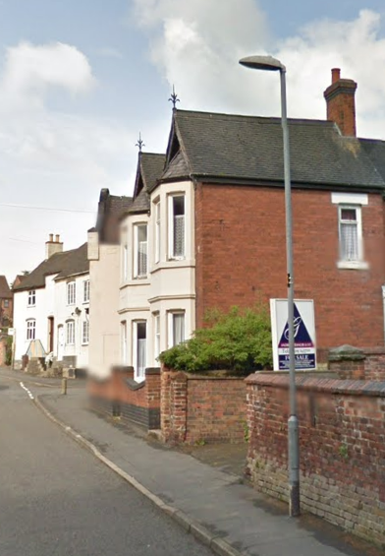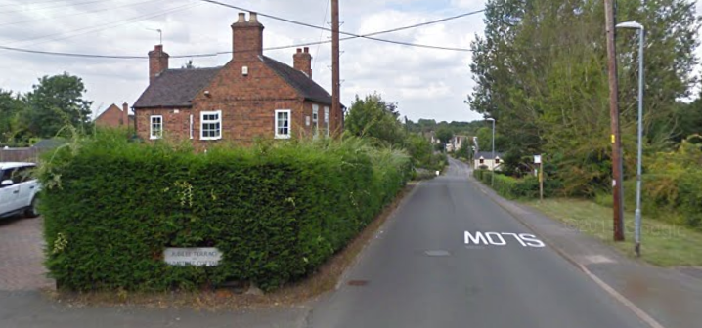

LOCATION | LAMP COLUMN | COMMENTS
School Street, Oakthorpe | 7 | No - We would not install MVAS structures near and within proximity to a 20mph school safety zone. There are a number of ‘SLOW’ markings on the carriageway along School Street which act as a visual reminder to drivers to reduce vehicular speeds. Parking outside schools act as natural traffic calming deterrent as vehicles are required to stop/give-way to on-coming vehicles.  The layout of the road has a series of bends along its length and parked vehicles and as such is not conducive to high end vehicular speeds.
School Street, Oakthorpe |  | No – As above
Measham Road, Oakthorpe (into village – near New St) | 43 | Yes
Measham Road, Oakthorpe (into and out of village – School St end) |  | No – Already one in situ 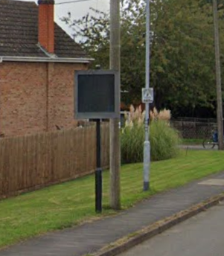

School Street, Oakthorpe Measham Road, Oakthorpe
– Lamp Col 7 – Lamp Col 43
