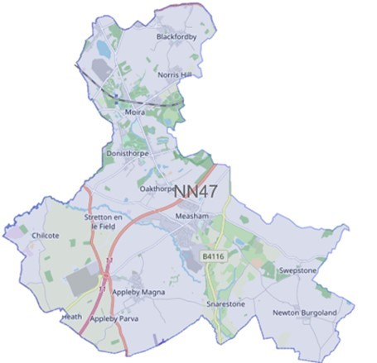

Issue: February 2024

Forest Beat

Newsletter

Your Local Team

What matters to you

SGT Gary Sirrell

PC Russ Leech

PC Owain Jones

PCSO Maddie Fearn

We have listened to you and the concerns you raised and will prioritise the following in January 2024 through to March 2024

Priority 1: ASB – Moira Furnace
Anti-social behaviour at Moira Furnace in particular off-road bikes and drug taking.
What we are going to do: Complete targeted patrols to disrupt and challenge behaviour. Intelligence development. Challenge those involved and work with partner agencies to implement outcomes.

Priority 2: Drug Dealing
Drug dealing around the Oakthorpe area.
What we are going to do: Complete targeted patrols to disrupt and challenge behaviour - Intelligence development. Challenge those involved and work with partner agencies to implement outcomes.

Priority 3: Vehicle Crime
Vehicle crime in Measham in particular motorbike thefts in the Atherstone Road area.
What we are going to do: Complete targeted patrols to disrupt and challenge behaviour - Intelligence development

Please click the link to show the latest available crime figures in the Forest Beat Area, beat team information, policing priorities and meeting and events.
https://www.police.uk/pu/your-area/leicestershire-police/forest/

News

To read all the latest news please follow the link
News | Leicestershire Police (leics.police.uk)

Crime Prevention

Visit our website for details on crime prevention https://www.leics.police.uk/cp/crime-prevention/
What we are doing
- Community Consultations to hear your views which assists us in priority setting in the future.
- Regular speed checks
- Regular patrols of hotspot ASB area’s
- Visiting schools, youth groups and community meetings
- Regular patrols of local park areas.
- We plan to be visible in crime hotspots across the area to reduce criminal behaviour.

Please help the Forest beat to understand your concerns by completing the following surveys.
- Confidence Survey Your Views Survey

POLICE REPORT
- Windmill Close, Albert Village – theft of vehicle
- Co-op, Shortheath Road, Moira – theft of food items
- Shortheath Road, Moira – theft of van
- Sarahs Wood, Moira – off road bike in woodlands
- Horse Lane, Measham – Anti-social behaviour
- Appleby Magna Allotments – sheds and greenhouses broken into, and tools stolen.
- Norris Hill, Moira – off road bikes
- Moira Road, Donisthorpe, stolen vehicle
- Francis Lane, Newton Burgoland – stolen vehicle
- Shortheath, Moira – items stolen from vehicle overnight
- Buzzard Close, Measham – items stolen from vehicle
- Norris Hill, Moira – theft of tools from garage

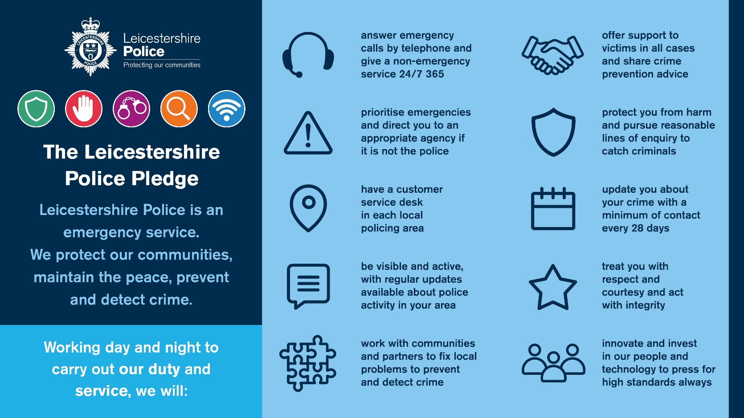

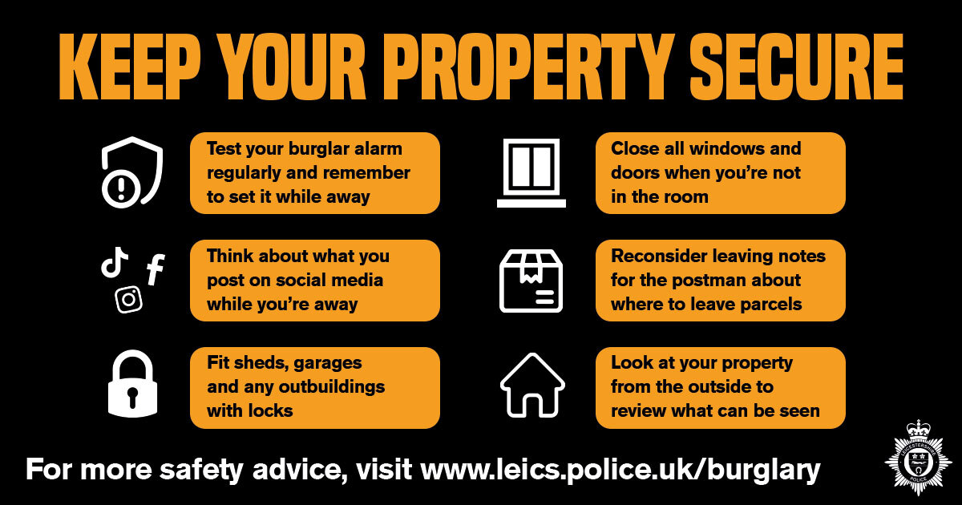

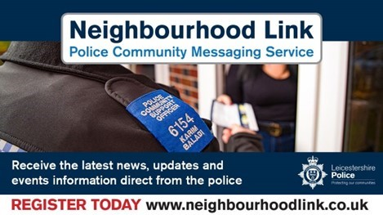

Neighbourhood Link is a community messaging service from Leicestershire Police that provides news and
Information about policing activity or initiatives, crime prevention advice as well as major incidents affecting your area.
Through this service you can receive messages from your local Neighbourhood Policing Team, local police or, in the event of a major incident or event affecting the whole of Leicestershire, from a partnership of agencies known as the Local Resilience Forum.
In order to receive messages you will need to register your details. Registration is free and simple to follow.

- Sign up to Neighbourhood Link https://www.neighbourhoodlink.co.uk/
- If you are already registered you can amend your details
- Request a reminder if you have forgotten your username or password • You can unsubscribe from the service at any time

Do you use a ‘community whatsapp group’? If so please consider sharing neighbourhood link information on there to encourage others to join.
Neighbourhood Link is not able to receive messages and you should not use it to contact the police. In an emergency always dial 999. If you wish to contact Leicestershire Police in other circumstances, for example to speak to local police or seek advice on police matters, you can call us by dialling 101 on your telephone.
•If you are already registered you can amend your details
•Request a reminder if you have forgotten your username or password
•You can unsubscribe from the service at any time
Neighbourhood Link is not able to receive messages and you should not use it to contact the police. In an emergency always dial 999. An emergency is when a crime is happening, someone suspected of a crime is nearby, someone is injured, being threatened or in danger.

If you wish to contact Leicestershire Police in other circumstances, for example to speak to local police or seek advice on police matters, you can call us by dialling 101 on your telephone.

