839705 Various Road, Oakthorpe, Donisthorpe & Acresford
LOCATION | LAMP COLUMN | COMMENTS | PHOTOS
Measham Road, Oakthorpe | 43 | Other locations on Measham Road Declined on initial list | 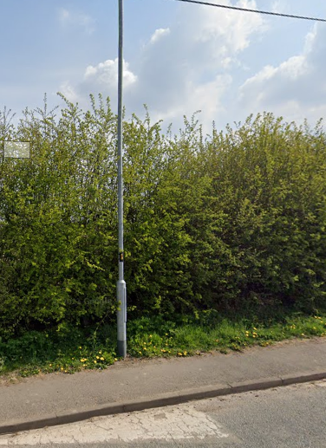
Measham Road looking towards Oakthorpe from Donisthorpe Crossroads | 69 or 70 | Please advise on the location and if lamp posts aren’t suitable, where a post can be located.  Speed on this straight stretch of road as vehicles leave Oakthorpe raised as concern by residents.
Ashby Road Donisthorpe Approaching the village from Willesley | 19 or 20 | Please advise of location in this area for a post if either lamp posts are not suitable.  Local residents living just inside the boundary have raised concerns about speeding as vehicles enter the village. School not far along the road and parents park along the roadside. | 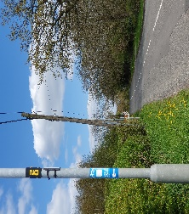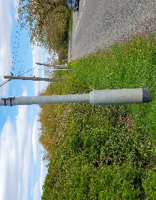
Church Street looking towards Acresford Road | 20 | Recommendation on previous list | 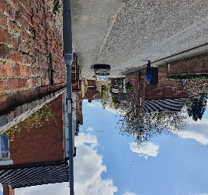
Acresford Road approaching entrance to Donisthorpe |  | Site visit with Highways requested months ago given proposed locations were refused. Still no progress with this key location of concern as data collected from a recent Speedwatch Scheme indicates. | Request Police camera along that road and location for a post
– Proposed MVAS Locations 2

