Proposed Projects Action Plan 2023-2027
Representing and Promoting the Interests and Well Being of the Parish

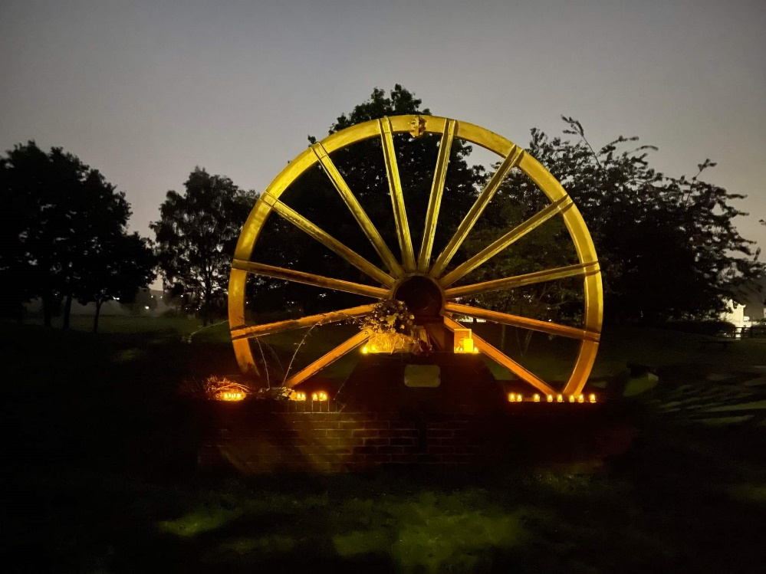
Action
Aim | Objective | Need | Timeframe | Other information
Ramscliff Donisthorpe - Football Pitch drainage improvements | To improve drainage on football pitch – possibly grant funding? | High | Ongoing. | AVFC have gained grant to improve pitch drainage over 6yrs 2023-2029
Residents request Ramscliff – is re spelt as they have believed for years Ramscliffe | To amend street sign to Ramscliff’e’ | Medium | Ongoing
Road Safety-  MVAS | Parish owns 4 MVAS (1 permanently on A444)  To investigate getting speed limits reduced on some roads in the Parish using MVAS data s evidence & publish on FB/Website report to police. | High | Ongoing. | Awaiting further lamppost or [post locations to be approved
Oakthorpe Play Area mesh fencing to be replaced with railings & install gate | To obtain money from housing development to pay for project. | High | Ongoing. | Manager chasing NWLDC.  Council to budget for needed repairs
Oakthorpe Play Area – play equipment | To provide a range of equipment suitable for younger children.  To obtain money from housing development to pay for project. | High | Ongoing. | Council to look at providing needed equipment and emergency repairs from budget
Maintenance of Parish Asset OLC | Parish Office Alterations to include: -  Install notice board at entrance.  CCTV upgrade/ heating/ window/ shutter  Consider installing solar panels funded through grants | Low | Review | Paused at present due to financial situation and other hurdles.
Aim | Objective | Need | Timeframe | Other information
Long term future of LC | Plan for alternative future without tenants.  Costs to turn into renting office space & council hub. Removal of showers/tanks | Medium | Ongoing | Build project pot
Replace notice boards | Rolling programme to replace old/damage notice boards council’s & communities. | Low | Ongoing | Monitor
ODAPC Profile | Raising profile |  | Ongoing | Boards/ Lanyards/ T-Shirts
Donisthorpe Street Railings | Improve look –gives negative impression of village. | High | Ongoing | Awaiting communication from LCC Highways  Concrete Faulty?
Friends of Parish Memorial Grounds | Support project.  Council budgeted to more/ re paint wheel. | Medium | Ongoing | Wheel
Allotment Boundary Management | PC owns all boundaries. | Medium |  | Contractor to cut back behind sheds monitor
IT equipment | Manager – council computer/laptop  Councillors having access to Chrome Books | Medium
Grounds Works | Proper path on Ramscliff field  Fencing in Orchard on boundary behind sheds.  Path in Orchard made wider for wheelchair access. | Medium
Aim | Objective | Need | Timeframe | Other information
Defibs at appropriate distance around Parish | Identified defib location –  Hill St Donisthorpe  Acresford | High | Ongoing
Access to deeds | Council to hold electronic copies of land deeds | High | Ongoing | Working with ex chairs/ solicitors to get statements.

Completed Projects |  | Updates
A444 & Acresford Road MVAS | MVAS in place | Done
Replace Notice Boards | Ivy Close & Church Street New Boards | Done
OCLC MUGA surface replacement | Unusable without – COVID funds covered costs. | Done
Parish Memorial Benches | £2000 Grant successful awaiting memorial ground project to complete. | Awaiting finishing of ground works
War Memorial Gates | Cleaned & re painted | Done
Day of Reflection 2022 | Benches fitted/ Trees planted | Done
Addition defibrillator for parish – Donisthorpe | DCG facilitated funding via NatWest -ODAPC to pay maintenance costs | Done
Improve welcome at entrance to parish | Planters delivered and planted with spring bulbs | Ongoing maintenance / planting
King Charles III Coronation | Trees planted at Donisthorpe & Oakthorpe School & Acresford Memorial Garden with plaques | Plaques installed
MVAS purchased for Oakthorpe & Donisthorpe | Active in villages. | Done  Awaiting other post/ locations approved

