839705 & 887484 Various Road, Oakthorpe, Donisthorpe & Acresford – Proposed MVAS Locations 2

LOCATION | LAMP COLUMN | COMMENTS | PHOTOS
Measham Road, Oakthorpe | 43 | Other locations on Measham Road Declined on initial list  Yes – this location was approved | 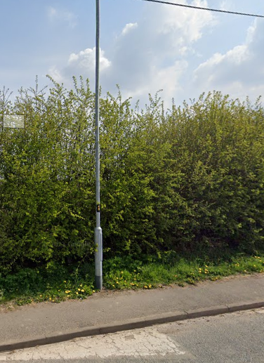
Measham Road looking towards Oakthorpe from Donisthorpe Crossroads | 69 or 70 | Please advise on the location and if lamp posts aren’t suitable, where a post can be located.  Speed on this straight stretch of road as vehicles leave Oakthorpe raised as concern by residents.  No – already 30 yellow backed terminals, school safety sign and give way sign all too close.  Furthermore, we cannot give permission for an MVAS within national speed limit. Also, we would need to consider not placing them within a 100 metres of a speed limit change.  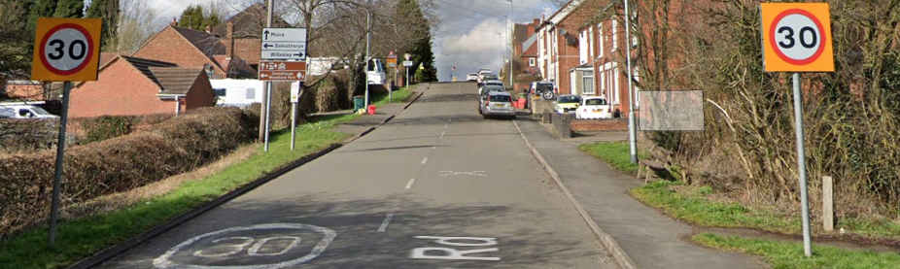
Ashby Road Donisthorpe Approaching the village from Willesley | 19 or 20 | Please advise of location in this area for a post if either lamp posts are not suitable.  Local residents living just inside the boundary have raised concerns about speeding as vehicles enter the village. School not far along the road and parents park along the roadside.  Either Lamp columns are fine. | 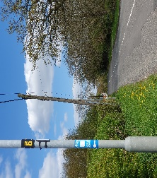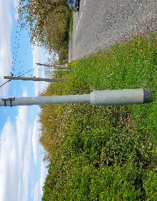
Church Street looking towards Acresford Road | 20 | Recommendation on previous list  Yes | 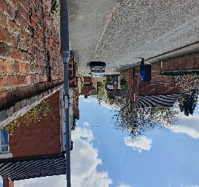
Acresford Road approaching entrance to Donisthorpe |  | As previously mentioned, Google street view up to 2012. We are aware of the new development at this location, however, our records show that this stretch of Acresford Road is subject to the national speed limit. We cannot give permission for an MVAS within national speed limit. Also, we would need to consider not placing them within a 100 metres of a speed limit change. | Request Police camera along that road and location for a post

