ben@bbtrees.co.uk www.bbtrees.co.uk

Duty of Care Arboricultural Survey:

Oakthorpe, Donisthorpe and Acresford Parish Council

Prepared for:
Oakthorpe, Donisthorpe and Acresford Parish Council
Oakthorpe Community Leisure Centre
Measham Road
Oakthorpe
Swadlincote
Derbyshire
DE12 7RG

Document reference: 636-21, Revision 1 (11 October 2022)

The Stable, 1 Alma Street, Melbourne, Derby, DE73 8GA
Oakthorpe, Donisthorpe and Acresford Parish Council

General notes and introduction

1.1 This survey has been undertaken for Oakthorpe, Donisthorpe and Acresford Parish
Council, Community Leisure Centre, Measham Road, Oakthorpe, Swadlincote,
Derbyshire, DE12 7RG. I received instruction from Kelly Grove, Parish Council Clerk on 09 September 2021. The requirement was to undertake a duty of care assessment of the trees located at Parish Council maintained sites within the villages of Oakthorpe, Donisthorpe and Acresford.

1.2 This survey has been commissioned to evaluate the health and structure of trees at the selected sites, primarily in relation to the potential hazard they pose towards people visiting the open spaces or within neighbouring property. Under normal circumstances, it is recommended that the trees are formally re-inspected in summer 2024.

1.3 It is intended that the recommended remedial actions seek to bring the risk posed by predictable hazards within reasonable limits. Absolute safety is not a realistic goal and unpredictable failure of trees cannot be ruled out. It would be appropriate to review the reinspection period, undertaking ad hoc interim inspections where appropriate, following severe weather.

1.4 All the trees in this survey have been assessed from the ground. The survey is based on a purely visual assessment of the trees. Where relevant, specific recommendations for remedial tree surgery or management works are included.

1.5 Such recommendations are based on the conditions as observed at the time of inspection and are valid for the duration of the priority codes as set out in paragraph 2.1 from the date of inspection. Trees are living, dynamic organisms and are susceptible to adverse weather and changes to their growth environment.

1.6 The protective status of the trees contained within the survey should be confirmed with the Local Planning Authority. Initially, it appears that there are no Conservation Areas applying to any of the survey sites. I further understand that no tree preservation orders apply, although I have not checked this. Should any statutory protection apply, then it will be necessary to make the requisite application and receive written consent before any tree work is carried out.

Page 2 of 40
Document reference: 636 -21, Revision 1 (11 October 2022)
Prepared on Thursday 21 October 2021
Oakthorpe, Donisthorpe and Acresford Parish Council

Tree survey and assessment notes

2.1 The columns in the tree survey and assessment refer to the following items:

Tree number: Reference number as shown on the associated sketch plans, embedded within the survey report.

Common name Genus species: Identifies individual species by its common name, along with its botanical name in italics.

Tree height: Estimated height of the tree in metres.

Trunk diameter: Approximate diameter of the trunk at 1.5m above ground level, expressed in centimetres.

Branch spread: Approximate maximum radial spread of the crown expressed in metres.

Age: The estimated age, either young, semi mature, early mature, mature, over mature or veteran, shown as Y, SM, EM, M, OM or V respectively.

Physiological condition: Good, fair, poor or dying/dead, shown as A, B, C and D respectively.

Structural condition: Good, fair, poor or dangerous (eg collapsing, the presence of significant decay and/or defects), shown as A, B, C or D respectively.

Comments and recommendations: Including further investigations of suspected defects that require more detailed assessment and potential for wildlife habitat.

Priority codes to assist with budget management:
- Emergency to be completed as soon as is practical.
- High priority to be completed within 6 months.
- Medium priority to be completed within 12 months.
- Low priority to be completed ahead of the next survey.

The timescale for the commencement of these works is from the date this survey was originally issued.

Signed
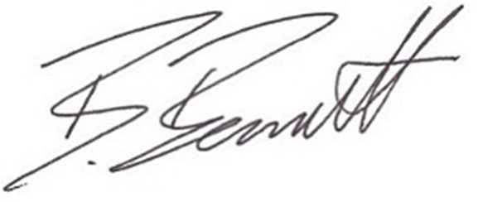

Ben Bennett, BSc (Hons) For, Cert Arb (RFS), MArborA Director, BB Trees Ltd
Page 3 of 40
Document reference: 636 -21, Revision 1 (11 October 2022)
Prepared on Thursday 21 October 2021

Oakthorpe

Playground, School Street, Oakthorpe

Figure 7: Sketch plan showing the approximate positions of trees surveyed at the Playground, School Street, Oakthorpe.

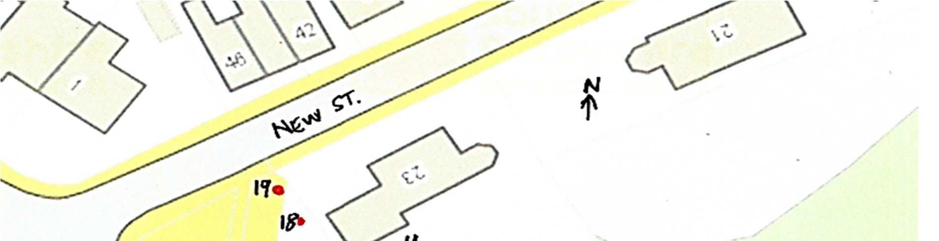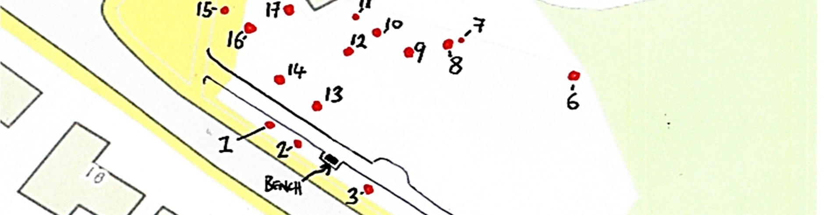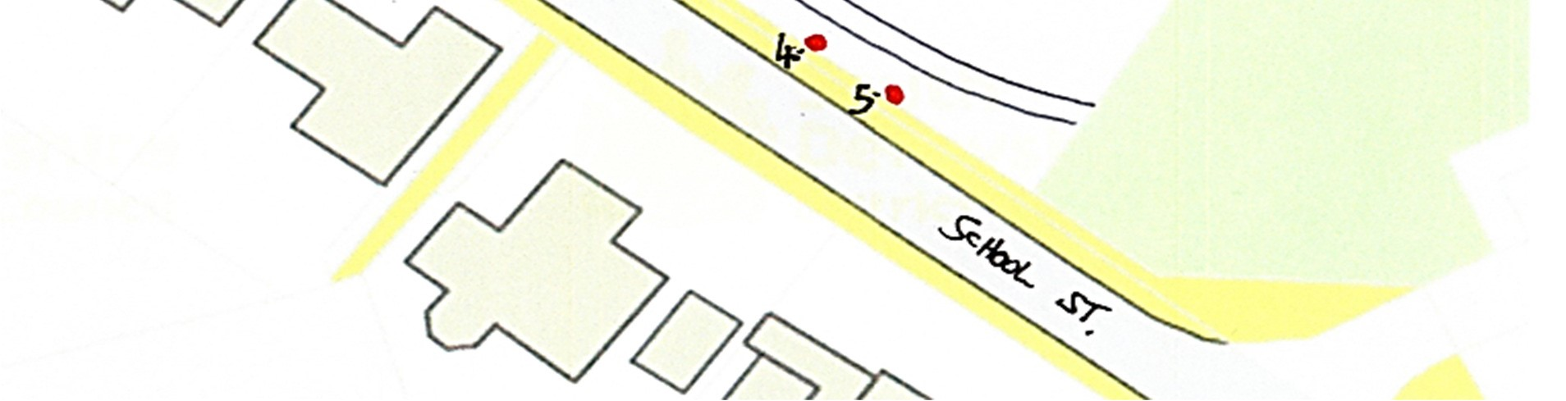

Tree number | Common name  Genus species | Tree height  (m) | Trunk diameter  (cm) | Branch spread  (m) | Age | Physiological condition | Structural condition | Comments and recommendations | Priority code
1 | Small leafed lime  Tilia cordata | 9 | 35 | 4.5 | SM/ EM | A | B | Significant near-to-surface roots including extending up to the edge of the railings/interface with the adjacent pavement. However, no significant displacement at present.  Multiple acute forks. However, all considered fair at present. Occasional crossing branch with potential for natural bracing to form.  No works required at present.
2 | Whitebeam  Sorbus aria | 7 | 20 | 3 | SM | B | B | Part suppressed crown. Potential for future girdling root.  No works required at present.
3 | Common lime  Tilia x europaea | 11 | 63 | 5 | EM | A | B | One of the dominant frontage trees.  Dense basal suckering obscuring lower trunk from detailed assessment. Congested crown centre with historic bird's nesting. Low branches previously reduced.  Surface root runs evident within an internal park path, which is tarmac surfaced, likely due to this tree.  Cut back basal suckers and ensure this is repeated ahead of next inspection. | 4
4 | Wild cherry  Prunus avium | 13 | 52 | 6 | M | B | B | Railings to boundary of park installed at a lower level than the root plate which at the time necessitated the cutting back of a significant root.  However, there does not appear to be any substantial associated decay.  Slight build up of organic detritus with a seedling growing out of it.  Potentially end weighted branches of near horizontal habit extending on the road side emanate from near this point.  Congested crown with much internal deadwood obscuring adjacent lamp column, although this appears to be defunct.  Remove as many of the dead or defective branches from the crown as is practicable and undertake a visual inspection of the main fork supporting the roadside branches.  Crown lift to give 3.5m clearance on the road side and 3m over the path and clip back from the lamp column head while working in the tree. | 3

ree number | Common name  Genus species | Tree height  (m) | Trunk diameter  (cm) | Branch spread  (m) | Age | Physiological condition | Structural condition | Comments and recommendations | Priority code
5 | Common lime  Tilia x europaea | 14 | 59 | 6.5 | EM | A | B | Low surface root extending towards pavement, which was likely cut back to facilitate the installation of the boundary railings some years ago. Some minor surface heave within the internal tarmac path, likely due to near-tosurface rooting from this tree.  A very dense and congested crown based upon a number of narrow forks with some signs of included bark, albeit windows of view to the upper crown structure were limited at the time of inspection. Low branches.  Crown lift all round to give approximately 3.5m clearance. Remove significant deadwood from the crown. | 3
6 | Wild cherry  Prunus avium | 10 | 51 | 7 | M | B | B | Co-dominant with offsite black poplar, which itself has previously been reduced.  The cherry has a crown bias towards the play apparatus. A few significant dead branches present within the crown plus some branch stubs following previous poor internodal pruning.  Remove significant dead branches and remove branch stubs to nearest natural branch collar. | 3
7 | Whitebeam  Sorbus aria | 4.5 | 12 | 1 | SM | C | C | Trunk grows at a list of around 45⁰ off the vertical with a significant bark wound at around 1.2m. Crown extends into that of the adjacent cherry and is heavily reliant upon companion shelter. Overall, the tree is only very modest.  Limited longevity. Retain only alongside adjacent cherry. Acceptable at present.
8 | Wild cherry  Prunus avium | 14 | 30  32  20 | 7 | EM | B | B | Multiple stemmed from base with two individual trunks running alongside one another for the first 0.7m of height. The close alignment of vertical stems has resulted in a congested crown with many crossing and chafing branches and only very small diameter deadwood.  Recently crown lifted with poorly aligned pruning cuts often removing part of the branch collar.  No works required at present.

Tree number | Common name  Genus species | Tree height  (m) | Trunk diameter  (cm) | Branch spread  (m) | Age | Physiological condition | Structural condition | Comments and recommendations | Priority code
9 | Turkey oak  Quercus cerris | 15 | 33 | 7 | SM/ EM | B | C | Establishing within a congested location with a strong growth bias in towards the park centre. However, co-dominant crown with following cherry.  Main fork at around 6m shows early indications of minor bark inclusion. Dead branches evident on the suppressed crown side.  Target prune lowest near horizontal branch back to swelled collar.  Selectively reduce the next lowest branch, shortening its outermost 1.5m of growth.  Remove obvious dead branches. | 3
10 | Wild cherry  Prunus avium | 14–15 | 51 |  | M | B | B | Part suppressed on park side of crown by previous Turkey oak resulting in a high volume of internal deadwood. Crown growth bias over boundary towards 23 New Street. Branches extending close to dormer gables.  Remove deadwood and sever establishing ivy.  Shorten lowest branches to give around 2–3m clearance from the neighbouring dormers while working within the tree. | 3
11 | Whitebeam  Sorbus aria | 7 | 10 | 2 | SM | D | D | Dead tree.  Remove. | 3
12 | Sycamore  Acer pseudoplatanus | 13 | 31 | 6 | EM | B | B | Leaves were turning due to autumnal senescence at the time of inspection. However, tree may be a variegated variety such as 'SIMON LOUIS FRERES', but it would be necessary to check this in the growth season.  Old bark wound at around 1m. Limited radial branch spread due to congested location. However, free from significant defect at present.  No works required at present.
13 | Turkey oak  Quercus cerris | 15 | 46 | 7 | EM | A | B | One of the larger trees in the park, yet still with extensive future growth potential.  Previously crown lifted to a reasonable standard. Co-dominant stems above around 7m. Side branch at around this height on the road side suspected to have a potentially weak union. However, the outboard branch is relatively well sheltered at present.  No works required at present.
Tree number | Common name  Genus species | Tree height  (m) | Trunk diameter  (cm) | Branch spread  (m) | Age | Physiological condition | Structural condition | Comments and recommendations | Priority code
14 | Silver birch  Betula pendula | 12–13 | 19  14  20 | 3–4 | EM | B | B/C | Minor bark wounds to lower stems. Three stems emerge at around 0.4m above ground level. Some clear included bark between the two main unions.  However, relatively sheltered at present.  No works required at present.  Pay particular attention to tree during future monitoring.
15 | Silver birch  Betula pendula | 10 | 22 | 4 | SM | B | B | Co-dominant crown. Slight bias towards park boundary.  No works required at present.
16 | Turkey oak  Quercus cerris | 11–12 | 37 | 4–5 | SM | B | B | A drawn up specimen due to the congested location. The upper crown is the only example within the park based upon a single leading section of stem.  Small diameter deadwood throughout.  No works required at present. Significant future growth potential.
17 | Wild cherry  Prunus avium | 14 | 44 | 6–7 | M | A | B | Close to neighbouring property.  Lowest branch on this side recently removed with a very poorly effected pruning wound which is part split.  Only very small diameter deadwood present in crown.  No works required at present.
18 | Whitebeam  Sorbus aria | 8 | 12 | 2.5 | SM | B/C | B | Tall, drawn up tree. Minimal crown. Heavily reliant upon companion shelter provided by adjacent cherries.  Retain only alongside adjacent cherries. No works required at present.
19 | Wild cherry  Prunus avium | 13 | 48 | 6.5 | M | A | B | Growing within the tapering corner of the park.  Minor pockets of dysfunction between root buttresses. Ground ivy around base. Co-dominant stems above 3m. Only very small diameter deadwood.  Minimal clearance from gable end of neighbouring garage.  Prune back to give around 1.5m clearance to gable end of neighbouring garage and crown lift all round to give around 3m clearance.  Reassess for deadwood removal at next survey interval. | 4

