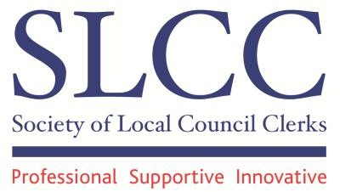

THE CLERK’S WORKING HOURS SURVEY

NEC is recommended to
endorse the recommendations contained in the report of the Working
Group and to thank all its members for their considerable efforts in its
compilation
.

At the
May

meeting of NEC
it was
agreed to establish

a Working Group
:

“To consider in detail
the quantitative and qualitative results of the SLCC’s Mem
be
rs’ Working Hours Survey and to
make re
commendations to the SLCC’s NEC

and subsequently to the National Association of
Local Councils a
nd One Voice Wales on
new national recommendations to all member
councils on

i)

the way in which they should recompense clerks and deputising officers (both full
and part
-
time) who undertake working hours additional to their contracted hours

ii)

recommended min
imum hours for part
-
time clerks in a variety of circumstances and

iii)

any other matters which the Working Group considers to be relevant.”

The Working Party has been deliberating in detail since then by way of teleconferences and
exchange of emails. It a
lso conducted a second brief survey of part
-
time clerks in order to
validate its initial conclusions. The Group’s final report is attached. Its recommendations were
agreed unanimously
and have been forwarded to the C
h
ief E
xecutives of the three principal
s
ector bodies with the wish that they can now be adopted formally with a view to a joint circular
being issued to every Council in England and Wales prior to them setting their budgets for
2014/15.

Finally I would like to record my appreciation of the
contr
ibutions of all Group members who
also helped to make it a most productive and enjoyable exercise working together.

Richard Walden

Communications Officer

J

To the Chief Executives of:
National Association of Local Councils
One Voice Wales and
Society of Local Council Clerks

REPORT OF THE WORKING GROUP ON THE CLERK’S WORKING HOURS

- Membership
Lis Moore, SLCC Deputy National Employment Advisor
Sarah Jeffries, SLCC Smaller Councils Clerk
Alison Melnyczuk, SLCC Medium Councils Clerk
Helen Ball, SLCC Larger Councils Clerk
Gwilym Rippon, SLCC Welsh Clerk
Kim Bedford, Gloucestershire Association of Town and Parish Councils
Danny Moody, Northants County Association of Local Councils
Paul Egan, Deputy Chief Executive and Resources Manager, One Voice Wales
Richard Walden, SLCC Communications Officer (convenor of the Group)

- Principal Recommendations:

  - (see paragraph 6) that the minimum hours per month for part-time Clerks to various categories of local councils for undertaking basic duties should be:
Profile of Council Minimum Hours per month
One meeting every two months – minimal services 17.5
One meeting a month – minimal services 26
One meeting a month – limited services (such as
allotments, village green) – no employees 30.5
Two or more meetings (council and committees) a
month - limited services 33
Two or more meetings (council and committees) a 35 month – several services (such as village hall, recreation
ground)

  - (see paragraph 8) that the provision of an annual Appraisal and the treatment of additional hours, be included as a matter of urgency in the next review of the NALC/SLCC National Terms and Conditions Agreement

  - (see paragraph 9) that the sector bodies undertake urgent research into all forms of efficiency measures, both large and small, which have been introduced by member councils in recent years with a view to disseminating best practise throughout the sector.

- Introduction
Local Councils are being encouraged to take on additional services for the community, both as a result of the devolution of services from Principal Authorities and from new powers available under the Localism Act (in England). In Wales additional duties may be imposed
by the Welsh Government affecting Clerks’ workloads. In most cases these services are managed by the Clerk, which entails additional hours of work that are not always reflected in the employment contract.

All sector bodies have been keen to encourage local councils to embrace the opportunities presented and to undertake more for their local communities, but capacity is clearly an issue that is frequently reflected in increased time pressures. The problem of significantly increased workloads on unchanged resource levels such as the same number of hours or same number of employees is creating real pressure, which ultimately will lead to issues with retention and recruitment levels in the profession.

Aware of the growing concern of its members on this issue, SLCC earlier this year invited its members to complete an on-line survey in order to establish an evidence base which provides quantifiable examples to a case for action.

4. The Survey results

The survey was completed by 1,125 members which is one of our highest ever returns experienced by SLCC and nearly twice the number who completed each of its past two biennial members’ surveys, doubtless signifying the importance of the subject to clerks.

The headline results were:

- 96% of part-time respondents work additional hours beyond contractual hours
- 92% of full-time respondents work extra hours additional hours beyond contractual hours
- 84% of respondents say their workload has increased in past 5 years
- Both full-time and part –time respondents say that, on average, they work 3-5 hours extra per week. This suggests the problem is proportionately greater for part-time clerks
- 54.4% of those working additional hours have raised the matter with their Council

A more detailed summary of the survey responses can be found at Appendix A. The survey also sought detailed information from part-time clerks about the number of hours they worked undertaking basic regular tasks and this information has formed the empirical basis for the recommendations concerning part-time hours later in this report.
5. The Working Party

The survey results were discussed by the SLCC’s National Executive Council (NEC), in a workshop session at the SLCC Practitioners Conference in February 2013 and informally with officers of the National Association of Local Councils and One Voice Wales. There was a clear willingness across the sector to take action in response to the survey results. SLCC’s NEC accordingly agreed to invite representatives from across the sector to take part in a working group with the following terms of reference.

“To consider in detail the quantitative and qualitative results of the SLCC’s Members’
Working Hours Survey and to make recommendations to the SLCC’s NEC (if possible at its
July 2013 meeting) to the National Association of Local Councils and One Voice Wales on new national recommendations to all member councils on
- the way in which they should recompense clerks and deputising officers (both full and part-time) who undertake working hours additional to their contracted hours
- recommended minimum hours for part-time clerks in a variety of circumstances and
- any other matters which the Working Group considers to be relevant.” The Group has met by way of teleconferences and exchanges of emails.
6. Part-time working – recommended basic hours
The working group identified that the role of clerk comprises “basic duties” and “additional duties”. “Basic duties” are those common to most clerkships, e.g. meeting preparation whereas “additional duties” vary from clerkship to clerkship depending on the size of council and the services and functions they provide. An example of “additional duties” would be managing a burial ground. Based upon a detailed analysis of the results of the survey (see Appendix B) the Group RECOMMENDS that the minimum number of hours per month for part-time Clerks to various categories of local councils undertaking “basic duties” should be:
Profile of Council Minimum* Hours per month
One meeting every two months – minimal services 17.5
One meeting a month – minimal services 26
One meeting a month – limited services (such as
allotments, village green) – no employees 30.5
Two or more meetings (council and committees) a
month - limited services 33
Two or more meetings (council and committees) a
month – several services (such as village hall, recreation
ground) 35

In making the above recommendations we would stress that each Council is unique and therefore the duties undertaken by the Clerk, or paid Officer can vary enormously. There are however some similarities – preparation for meetings, production of minutes, reports, accounts etc. The table above sets out the minimum amount of time that is required to undertake these basic tasks to the required standard. These figures have been compiled following a comprehensive survey of Clerks’ actual working hours across England and Wales. In addition to those duties highlighted in Appendix B there will be a wide range of other duties undertaken by Clerks which will be directly influenced by the policies of Councils as well as internal issues and external engagement factors. These duties could include arranging a litter pick or the communities ‘In Bloom’ entry, compiling a response to the Local (Development) Plan, being actively involved in a Community/ Parish/ Town Plan or Village Design Statement or even running a market or being involved in a local carnival or community event. Internal issues that can significantly increase a Clerk's workload usually relate to HR matters (e.g. recruitment/discipline) and external engagement matters might include responding to freedom of information requests. It is important to recognise that there are many internal and external influences that can and do affect Clerk's workloads and it is extremely important that remuneration levels properly reflect the time contribution of the Clerk.
Note * “Minimum” hours are very much influenced by the duration time of meetings and can be subject to significant variance
- National Minimum Wage

Our survey of part-time Clerks has revealed that, taking into account the hourly rate of pay and actual hours worked compared to contracted hours, there are a disturbing number of council clerks who are working for less than the minimum wage. We would therefore urge that any council in such a situation gives urgent consideration to our recommendations about part-time hours. HMRC have a duty to enforce the National Minimum Wage Act.
The Pay and Work Rights Helpline will refer any relevant complaints from workers to HMRC. National minimum wage compliance officers can carry out detailed investigations. If workers are found to be owed money, HMRC will issue a notice of underpayment to the employer. In 2011-12 they served 879 notices to employers detailing how much they owed their workers. The majority of enquiries were settled on receipt of this notice but prosecution is HMRC’s ultimate sanction.
- Determining the actual hours a Clerk should be working
To assist Councils in better understanding the precise activities which their Clerk will be performing in each of the time categories referred to in the survey at Appendix B we have indicated at Appendix C a fuller description of those broad headings.
Based upon the activities in the previous appendices, we have included at Appendix D a model form of regular time sheet which clerks could use. It is, however, most important that all duties have been approved previously by the Council.

Where a Council or its Clerk believes that additional hours are being worked regularly we would recommend that the Clerk maintains a weekly timesheet over a period of time to establish the precise average number of hours. Some examples of timesheets which have been used for this purpose are attached at Appendix E. At Appendix F we have also included a model business case which has been used successfully to secure additional paid hours.
We have further provided at Appendix G some suggested words which may be inserted in a Clerk’s contract with regard to Appraisals and the treatment of additional hours.
The group, however, believes that the need for a regular review of the Clerk’s working hours and the conduct of annual appraisals* should be formally recognised and we therefore RECOMMEND that these matters be included as a matter of urgency in the next review of the NALC/SLCC National terms and Conditions Agreement.
Note *Appraisals often identify training requirements of employees and we believe it is important for Councils to appropriately budget for addressing the approved training needs of their employees. It should be noted that Councils introducing new appraisal schemes should consider the benefits of arranging for members and officers to be trained in its use prior to implementation.
9. Efficiency Savings
The Group is acutely aware that all principal councils, faced with substantially reduced funding in recent years, have been forced to develop ever greater efficiency measures. Local Councils have largely been spared from these exercises, however in a time of general public service constraints and in the light of clear evidence of Clerks working substantial additional unpaid hours, we believe that our national bodies should be promoting efficiency measures specific to our sector. Because a Council has always operated in a particular manner or conducted its business in a specific way, it does not follow that it should continue to do so in future. We therefore RECOMMEND that urgent research is undertaken into all forms of efficiency measures, both large and small, which have been introduced by member councils in recent years with a view to disseminating best practise throughout the sector.

Index of Appendices

Appendix “A” Working Hours Survey – Detailed Results for Individual Questions Page 7

Appendix “B” Detailed Analysis of Responses to the Minimum Number of Hours Worked
by Part Time Clerks Page 9

Appendix “C” Description of Specific Duties Page 12

Appendix “D” Time Sheet Page 14

Appendix “E” Examples of Time Sheets Page 15

Appendix “F” Example of a Business Case for Additional Paid Hours Page 18

Appendix “G” Proposed Wording Regarding Working Hours in the Appraisal Page 20

Appendix “A”
Working Hours Survey - Detailed Results for Individual Questions

How are you recompensed for your extra hours?

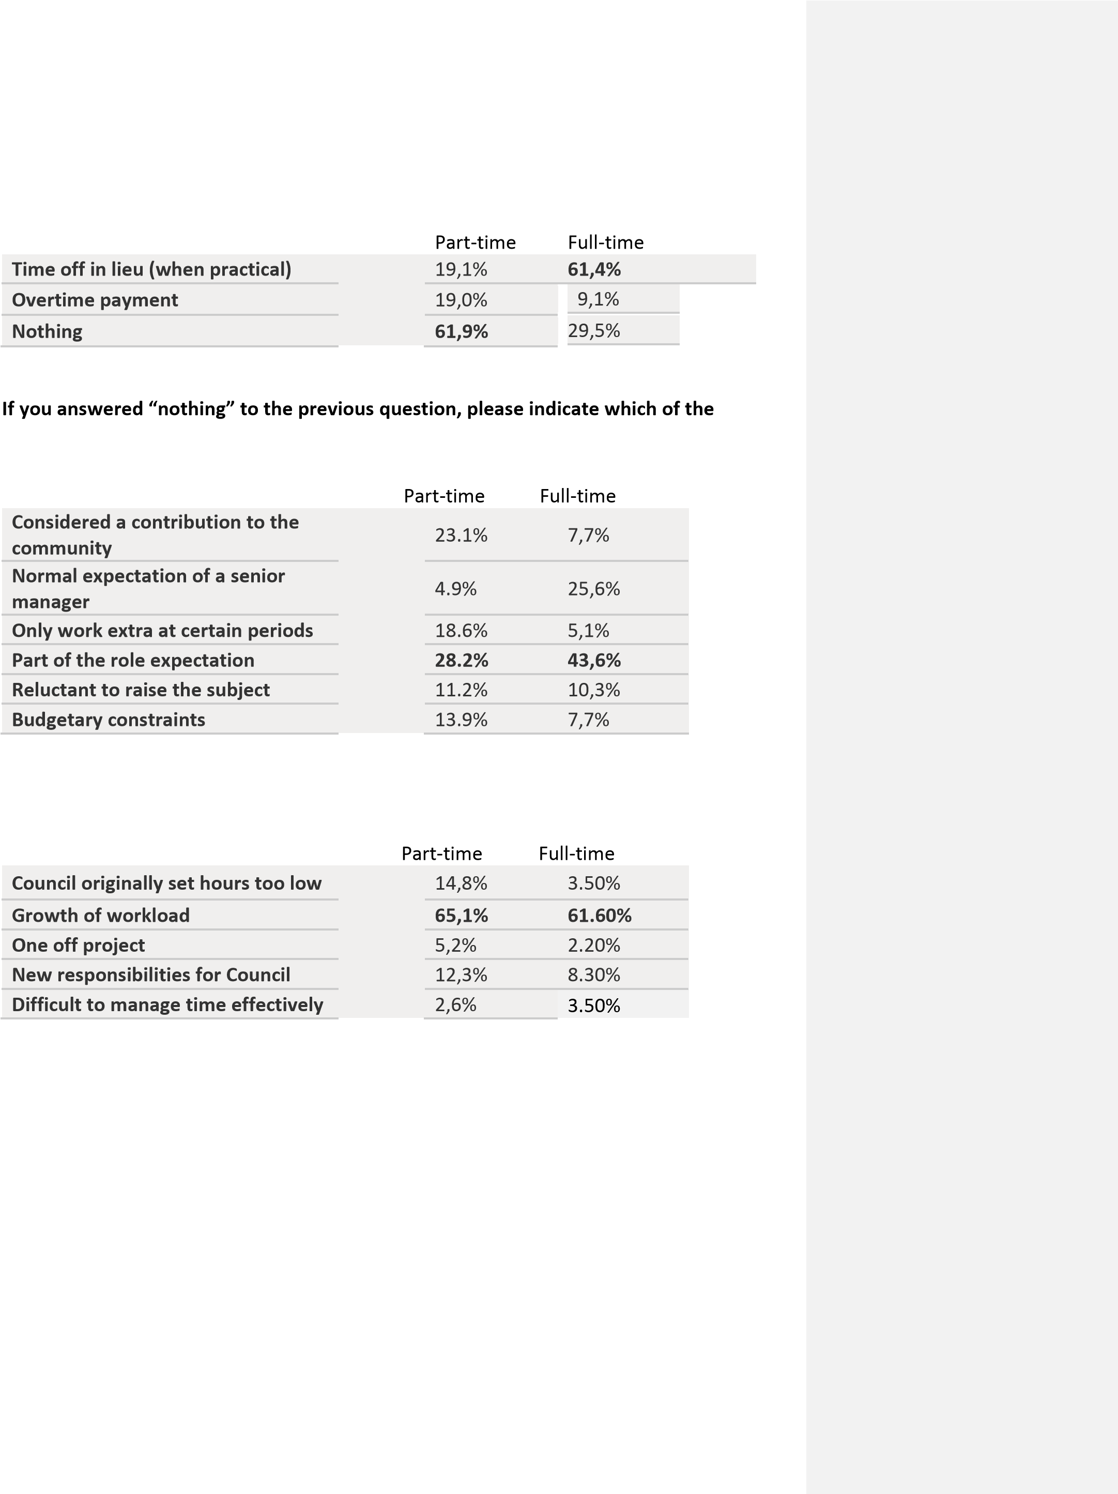
following most closely represents why this is the case?

What in your opinion are the likely reasons for the additional hours?
What is your Council’s attitude to your additional hours?
Part-time Full-time
All of my Councillors are aware of my additional hours and ignore them | 10,9% | 32.00%
All of my Councillors are aware of my additional hours and want to address the issue | 25,8% | 10.50%
The Chairman or some of my Councillors are aware of my additional hours and ignore them | 15,4% | 21.50%
The Chairman or some of my Councillors are aware of my additional hours and want to address the issue | 29,9% | 26.80%
None of my Councillors know about my additional hours | 17,9% | 9.20%

Appendix “B”
Detailed analysis of responses to the minimum number of hours worked by part time Clerks
One meeting every two months – minimal services
 | less  than  1 hour | 1-2 hours | 2-3 hours | 3-4 hours | 4-5 hours | 6-8 hours | 8-10 hours | 10-12 hours | 12-14 hours | 16-18 hours | 18-20 hours | 20-25 hours | 25 -  30 hours | 30 -  40 hours | Over  40 hours |  | Response | Weighted
 |  |  |  |  |  |  |  |  |  |  |  |  |  |  |  |  | Count | Average
 | 0.5 | 1.5 | 2.5 | 3.5 | 4.5 | 7 | 9 | 11 | 13 | 17 | 19 | 22.5 | 27.5 | 35 | 40
Servicing Meetings | 2 | 14 | 24 | 16 | 10 | 16 | 9 | 5 | 1 | 0 | 1 | 0 | 1 | 0 | 0 |  | 99 |  | 4.95
Financial Management | 17 | 43 | 27 | 12 | 11 | 7 | 1 | 2 | 0 | 0 | 0 | 0 | 0 | 0 | 0 |  | 120 |  | 2.60
Administration | 9 | 12 | 16 | 14 | 9 | 10 | 10 | 6 | 4 | 5 | 6 | 2 | 0 | 0 | 2 |  | 105 |  | 7.18
Answering public enquiries | 52 | 27 | 13 | 7 | 1 | 2 | 0 | 0 | 0 | 0 | 1 | 0 | 0 | 0 | 0 |  | 103 |  | 1.56
Managing/ supervising staff | 61 | 2 | 1 | 0 | 2 | 0 | 0 | 0 | 0 | 0 | 0 | 0 | 0 | 0 | 0 |  | 66 |  | 0.68
Other | 17 | 20 | 13 | 15 | 6 | 5 | 2 | 3 | 2 | 0 | 1 | 0 | 0 | 0 | 0 |  | 84 |  | 3.35
Total per month | 1 | 1 | 5 | 5 | 3 | 8 | 6 | 9 | 9 | 14 | 5 | 13 | 11 | 13 | 2 |  | 105 | 1 | 7.47
One meeting a month – minimal services
 | less  than  1 hour | 1-2 hours | 2-3 hours | 3-4 hours | 4-5 hours | 6-8 hours | 8-10 hours | 10-12 hours | 12-14 hours | 16-18 hours | 18-20 hours | 20-25 hours | 25 -  30 hours | 30-40 hours | Over  40 hours |  | Response | Weighted
 |  |  |  |  |  |  |  |  |  |  |  |  |  |  |  |  | Count | Average
 | 0.5 | 1.5 | 2.5 | 3.5 | 4.5 | 7 | 9 | 11 | 13 | 17 | 19 | 22.5 | 27.5 | 35 | 40
Servicing Meetings | 2 | 14 | 23 | 27 | 15 | 19 | 16 | 6 | 6 | 7 | 4 | 4 | 0 | 1 | 0 |  | 144 |  | 6.82
Financial Management | 13 | 31 | 28 | 28 | 19 | 10 | 5 | 5 | 4 | 0 | 2 | 2 | 0 | 0 | 0 |  | 147 |  | 4.16
Administration | 5 | 10 | 10 | 15 | 14 | 14 | 19 | 11 | 7 | 6 | 11 | 8 | 8 | 4 | 6 |  | 148 | 1 | 1.69
Answering public enquiries | 46 | 31 | 15 | 14 | 14 | 9 | 3 | 3 | 1 | 3 | 0 | 2 | 0 | 0 | 0 |  | 141 |  | 3.20
Managing/ supervising staff | 53 | 13 | 6 | 7 | 3 | 1 | 0 | 1 | 0 | 0 | 1 | 0 | 1 | 0 | 0 |  | 86 |  | 1.90
Other | 8 | 19 | 9 | 16 | 17 | 15 | 7 | 5 | 4 | 1 | 4 | 2 | 2 | 0 | 1 |  | 110 |  | 6.32
Total per month | 1 | 2 | 3 | 4 | 6 | 3 | 2 | 6 | 3 | 7 | 7 | 10 | 22 | 23 | 33 |  | 132 | 2 | 5.78
 |  |  |  |  |  |  |  |  |  |  |  |  |  |  |  |  |  | Page 9

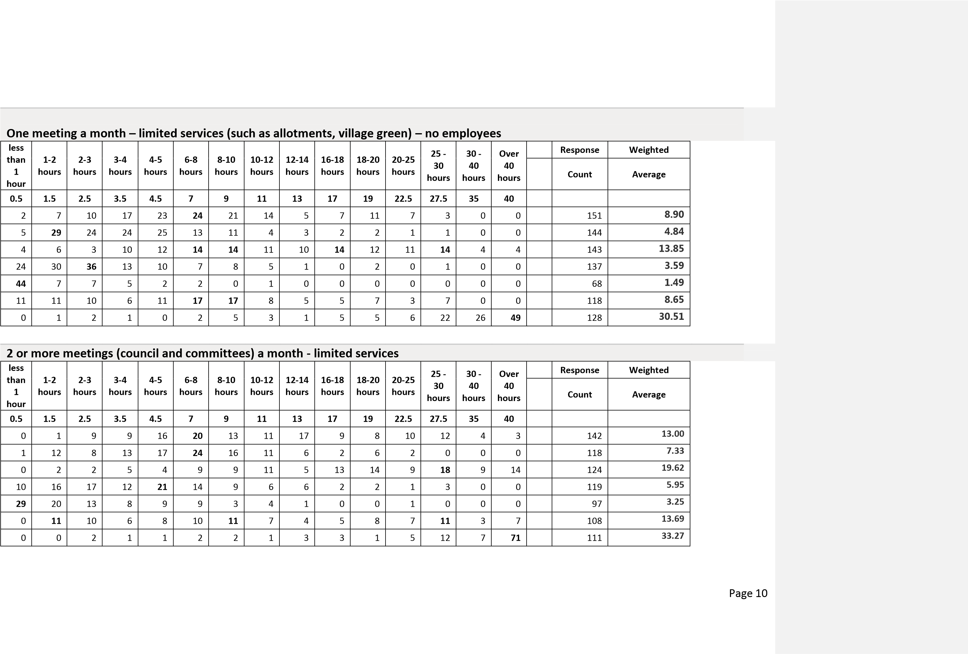
2 or more meetings (council and committees) a month – several services (such as village hall, recreation ground)
 | less  than  1 hour | 1-2 hours | 2-3 hours | 3-4 hours | 4-5 hours | 6-8 hours | 8-10 hours | 10-12 hours | 12-14 hours | 16-18 hours | 18-20 hours | 20-25 hours | 25 -  30 hours | 30 -  40 hours | Over  40 hours |  | Response | W | eighted
 |  |  |  |  |  |  |  |  |  |  |  |  |  |  |  |  | Count | A | verage
 | 0.5 | 1.5 | 2.5 | 3.5 | 4.5 | 7 | 9 | 11 | 13 | 17 | 19 | 22.5 | 27.5 | 35 | 40
Servicing Meetings | 1 | 3 | 2 | 8 | 11 | 17 | 30 | 24 | 13 | 15 | 12 | 16 | 24 | 8 | 10 |  | 194 |  | 15.94
Financial Management | 1 | 7 | 10 | 17 | 19 | 21 | 26 | 25 | 10 | 6 | 14 | 9 | 2 | 2 | 1 |  | 170 |  | 10.01
Administration | 0 | 1 | 3 | 4 | 7 | 16 | 15 | 10 | 2 | 6 | 18 | 21 | 37 | 16 | 27 |  | 183 |  | 21.92
Answering public enquiries | 4 | 16 | 16 | 17 | 24 | 21 | 27 | 14 | 5 | 7 | 13 | 10 | 3 | 1 | 1 |  | 179 |  | 8.89
Managing/ supervising staff | 16 | 23 | 18 | 17 | 21 | 18 | 12 | 8 | 4 | 3 | 4 | 6 | 2 | 1 | 1 |  | 154 |  | 6.54
Other | 1 | 6 | 6 | 5 | 9 | 14 | 26 | 17 | 8 | 4 | 15 | 16 | 23 | 13 | 3 |  | 166 |  | 15.82
Total per month | 0 | 0 | 1 | 0 | 1 | 0 | 1 | 2 | 0 | 3 | 6 | 2 | 19 | 5 | 105 |  | 145 |  | 35.49
 |  |  |  |  |  |  |  |  |  |  |  |  |  |  |  | Page 11

Appendix “C”
Description of Specific Duties
SERVICING MEETINGS
Preparation of Council Agendas
Copying of Papers
Despatch Arrangements
Posting of Agendas on Council Noticeboards
Preparation time for meetings
Attendance at Meetings
Preparing Minutes of Council Meetings
Undertaking actions from Council Meetings
Organising Council and Committee Timetables
Filing of Papers from Council Meeting

FINANCIAL MANAGEMENT
Preparation of Budget
Monthly Bank Reconciliations
Obtaining Cheque Signatures
Checking of Invoices and Processing Cheques
Updating Accounts System
Budget Monitoring
Preparation of Financial Reports for Committee
Annual Statement of Accounts
Processing of Salaries and Wages Payments
HMRC Processes
HMRC Annual Employer Return/Issue of P60s
Start of Year Procedures
Preparing for Submission of End of Year Return
Working with Internal Auditor
Maintaining Financial Records
Invoicing for Hire of Facilities
Negotiation with Suppliers
Tendering/Procurement Arrangements
Banking Arrangements
VAT Returns

MANAGING STAFF
Health and Safety - Reviewing Risk Assessments
Regular Engagement with Staff
Annual Appraisal of Self
Training/Induction of Staff
Recruitment and Selection of Staff
Annual Appraisal of Staff
Temporary Cover for Hall Caretakers
Page 12

Dealing with Referred Matters by Staff
Organising Relief Cover
Briefing Discussions with Business Support Officer
Completion of Personal Timesheet
Wages Enquiries

ADMINISTRATION
Dealing with Crisis Issues/Special Issues
Obtaining Legal Advice
Dealing with Enquiries from the Public
Liaison with County Borough Council
Updating of Council Procedures
Liaison with Council Chair
Liaison with Committee Chairs
Dealing with Specific Councillor issues
Weekly General/Non Specific Matters

OTHER
Allowance for Leave/Bank Holidays
Sickness - Assumed Absence Rate of 5 days pa
Allowance of 2 full time days training
Keeping up to Date with Developments/Legal Changes
Attendance at SLCC Meetings

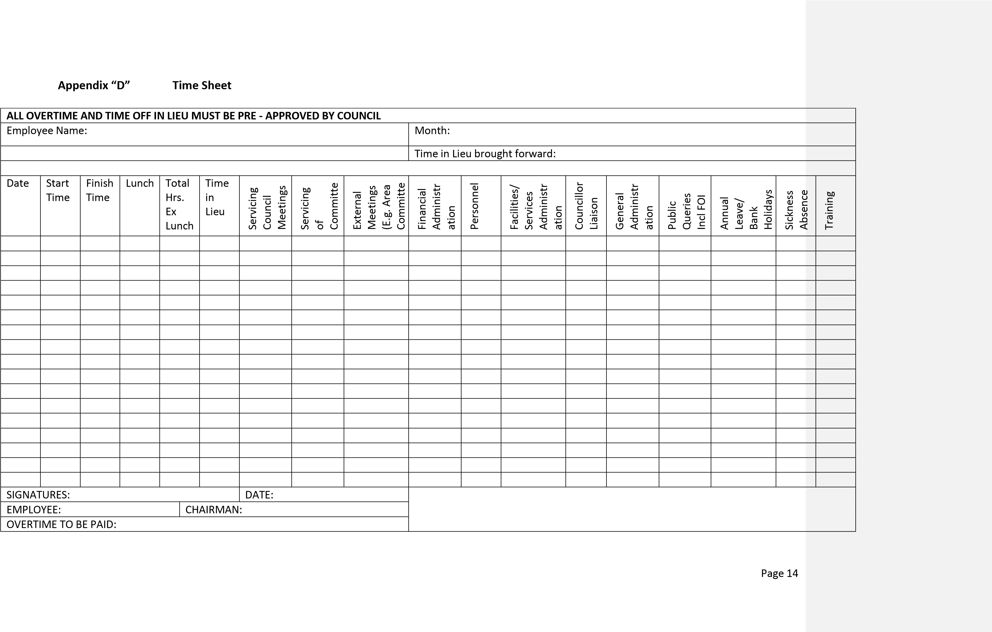

Appendix “E”
Example of Time Sheets
SCHEDULE OF DUTIES
SERVICING OF COUNCIL MEETINGS
Preparation of Council Agendas
Copying of Papers (five Councillors require hard copies)
Despatch Arrangements ( uploading to Website)
Posting of Agendas on Council Noticeboards
Preparation time for meetings
Attendance at Meetings
Preparing Minutes of Council Meetings ( Checking Minute Clerk)
Undertaking actions from Council Meetings
Organising Council and Committee Timetables
Filing of Papers from Council Meeting
SERVICING OF FINANCIAL COMMITTEE
Preparation of Agenda
Copying of Papers
Despatch Arrangements
Posting of Agendas on Council Noticeboards
Preparation time for meetings
Attendance at Meetings
Checking Minutes of Committee
Undertaking actions from Committee Meetings
Filing of Papers from Committee Meeting
EXTERNAL MEETINGS (Area Board Meetings/CATG and Market Towns)
Reading of Agenda
forwarding on Agendas and other paper work Preparation time for meetings CATG etc.
Attendance at Meetings as required
Report back to Council Meetings
AMENITIES AND PLANNING COMMITTEE
Preparation of Agenda
Copying of Papers ( for four Councillors)
Despatch Arrangements
Posting of Agendas on Council Noticeboards
Preparation time for meetings
Attendance at Meetings
Checking Minutes
Undertaking actions from Committee Meetings
Filing of Papers from Committee Meeting
FINANCIAL ADMINISTRATION
Preparation of Budget

Preparation of Agenda
Copying of Papers ( for five Councillors)
Despatch Arrangements
Posting of Agendas on Council Noticeboards
Preparation time for meetings
Attendance at Meetings
Checking Minutes
Updating Accounts Software
Preparation of Reports for Committee
Annual Statement of Accounts
Processing of Salaries and Wages Payments for 4 staff
HMRC Processes Payments P60 etc
Start of Year Procedures / updating Account Software etc
Preparing for Submission of End of Year Return
Working with Internal Auditor
Maintaining Financial Records
Invoicing for Hire of Facilities Tennis Court Bowls Club Sports Pavilion reclaiming Water rates form Tennant
Tendering/Procurement Arrangements Utilities etc
Banking Arrangements
VAT Returns
PERSONNEL
Health and Safety - Reviewing Risk Assessments on Clerk
Regular Engagement with Staff daily
Annual Appraisal of Self
Training/Induction of Staff
Recruitment and Selection of Staff
Annual Appraisal of Staff ( needs to be added as a yearly task)
Dealing with Referred Matters by Staff
Organising Relief Cover
Completion of Personal Timesheet ( needs to be actioned)allocate
FACILITIES/SERVICES ADMINISTRATION
Footpaths referrals to WC Officers
Festivals - Carnival/ Big Lunch/ Cycling Events
Maintenance Issues
Football Pitches
Grounds Contract/Parks/ Tree Management
ROSPA Inspections
Liaison with Contractors
COUNCILLOR LIAISON
Liaison with Council Chair
Liaison with Committee Chairs
Dealing with Specific Councillor issues/ Complaints
GENERAL ADMINISTRATION
Dealing with Post & Emails
Dealing with Crisis Issues/Special Issues

Obtaining Legal Advice
Dealing with Enquiries from the Public/Cemetery
Liaison with Principal Council
Updating of Council Procedures
Weekly General/Non Specific Matters
ALLOWANCE FOR TRAINING
Allowance
Keeping up to Date with Developments/Legal Changes
Attendance at SLCC Meetings
Total Hours Required Yearly excluding holiday allocation
ANNUAL LEAVE/BANK HOLIDAYS
Allowance for Leave/Bank Holidays
ALLOWANCE FOR SICKNESS ABSENCE
Assumed Absence Rate of 5 days pa
Total Hours Required Yearly excluding holiday allocation
Total Hours Required Yearly
Divided weekly

Appendix “F”

Example of a Business Case for Additional Paid Hours

BUSINESS CASE FOR THE INCREASE IN CLERKS
HOURS

Name
another

Parish
/ Community/ Town

Council ………………………..
-

Clerk

1.

SUBJECT

This Business Case seeks approval to extend the clerks hours from the current

hours to 8 hours per
4
week
.

2.

RECOMMENDATION

The recommendation is that the clerk’s hours are increased in line with the doubling of the council’s
work load due to an
increase of meeting times of the Council and the implementation of the
Parish
/Community

Plan.

3.

JUSTIFICATION

The Society of Local Council Clerks recommends that, for the basic job of clerk to the council, several
factors should be taken into account
. Clerks to even the smallest or inactive Councils will have
workloads which require a minimum of
four hours per week. With a civic population of between 251
–

, the Society of Local Council Clerks recommends 6.00 hours servicing meetings 4.00 hours fin
500
ancial
management, 4.25 hours administration work and 4.00 hours for other work. This workload calculates
out at 18.25 hours a month.

Another Clerk has kept a time sheet of the time working on administrative and finance duties over an
average month and has been recorded as 28.45 hours. This time does not include opening and reading
post or making telephone calls, it is purely time spent
working at the computer, actioning e
-
mails,
letters, agendas and minutes.

Another Council is far from an inactive Council and therefore the hours worked by the Clerk do not
currently match the hours paid monthly at present.

Comment [C1]:
I have used this
business case successfully for two parish
councils and have shared it with other
Clerks all of which have also had success
with it. I think it is clear and to the point.

Comment [C2]:
These hours came from
keeping a time sheet for a year which
highlig
hted the issue, it gives the Clerk an
area to make a clear statement on the hours
worked and required.

Comment [C3]:
This can be adjusted by
the Clerk to fit with the additional work
they are now actioning or used to highlight
specific areas of increase. One small
Coun
cil I covered had never had planning
meetings so by stopping the passing of an
envelope and correcting working practices
in other areas of the Council administration
it meant there had to be a move to have
monthly meetings instead of Bi monthly
meetings. N
o issues arose from the public
or Councillors when this decision had to be
made using this format.

Comment [C4]:
Using the SLCC
suggested hours obviously gave a good
guideline and I have since used the time
sheet previously circulated to action a
bench marking exercise

with a fellow Clerk
which came out exactly the hours the Clerk
believed she should be paid for. I think
using the spread sheet to allocate hours and
this business case to present it to Council
many smaller Council Clerks would feel
confident in taking thi
s action and Small
Council Clerks need help with formatted
paper work to clone.

Comment [D5]:
Should be updated to
reflect the new recommendations once
finalised.

4.

5.

6.
ALTERNATIVES

To decrease the meeting frequency would mean the council would not cover the work load and would
put the Parish Plan actions on hold completely. This action will decrease the functionality of the council
within the Another Parish.

COST
INFORMATION

The anticipated annual costs of the extended hours are expected to be in the order of £3,424 compared
to £1,661 at present.

COUNCILS
ENDORSEMENT

We believe that the increase in the clerk’s hours is imperative to the efficient

running of the
C
ouncil. I also believe that the recommendation made be

implemented from the 1
st

September 2013.

We believe that the clerk should work only four hours a week as the clerk’s

contract of
employment states implemented from 1
st

September 2013

*** Dele
(
te as necessary)

Signed ………………………… Date…………………..

Comment [C6]:
To put it in black and
white that the Council would not cover its
work load helped Councillors realise th
ey
were making a decision to be ineffective if
they did not approve it and no one wants to
make that decision.

Comment [C7]:
Cost obviously needed
to be included and I presented the draft
budget sheet for the Precept at the same
time.

Comment [C8]:
A clear endorsement
statement to

focus Councillors minds at the
end on their decision.

***

***

Appendix “G”

Proposed wording regarding working hours in the appraisal;
-

The annual appraisal provides an ideal opportunity for both the employer’s representatives (ie
;
councillors who are part of the staffing committee / chairman and vice chairman) and the employee to
have quality time together, outside of the day to day demands.

[
For general guidance on the appraisal see ‘Being a Good Employer’ page 30]

As part of this review, consideration and discussion should establish an understanding of working
practices and the pressure points for the proper officer, balanced with the planned objectives of the
council. From this, it should be possible to assess if a
djustments need to be made. For example,
additional hours to the contract, subject to agreement, or more resources. Thus triggering a review
from council which could mean additional staff.

There may be a need for the proper officer to provide evidence of

the current use of time to the
employer. There is no reason why a more frequent review of this issue cannot take place, should either
party require this. Essential to this process is an open and honest dialogue between the two parties, in
order for a good

understanding to be gained for effective working partnerships.

Proposed wording regarding additional hours and the contract. Based on Model contract 2011.

When the contract of employment is drawn up between the council and proper officer, council ne
ed to
make it clear who the proper officer is to contact for guidance on aspects of the employment terms ie;
hours worked.

The contract will indicate the hours per week expected [section 13] The council will have budgeted to
cover employment costs, so ho
urs worked in excess of the contract need to be approved by your
designated council representatives. The model contract [section14] describes how additional hours may be reimbursed, but does not indicate how the proper officer is to ensure recognition and approval of the additional hours.

Additional clauses should include guidance on hours those over contract which the proper officer may assume approval, with the appropriate time sheet as evidence, as opposed to those additional hours which need prior approval before worked. Council need to give clear guidance on how this process is to be actioned.

