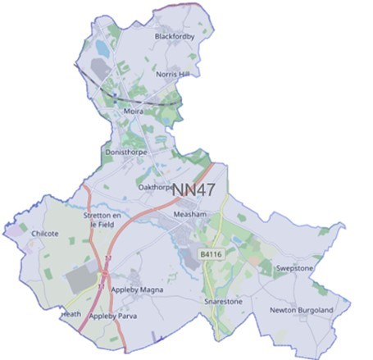
We have listened to you and the concerns you raised and will prioritise the following in October 2023.

Issue: November 2023

Forest Beat

Newsletter

Your Local Team

What matters to you

SGT Gary Sirrell

PC Russ Leech

PC Owain Jones

PCSO Maddie Fearn

Priority 1: ASB and Criminal Damage
You said: Criminal Damage and Anti-Social Behaviour at Woodlands Way, Moira and surrounding areas is of concern to you.
What we are going to do: *Targeted Patrols *Intelligence development

Priority 2: Road Safety
You Said: HGV’s breaching the weight limit was of concern to you on the Forest Beat
What we are going to do: *Targeted patrols - Partnership Working

Priority 3: Anti-Social Behaviour
You Said: Anti-Social Behaviour on High Street, Measham and surrounding areas.
CRIME FIGURES
Please click the link to show the latest available crime figures in the Forest Beat Area, beat team information, policing priorities and meeting and events.
https://www.police.uk/pu/your-area/leicestershire-police/forest/

News

To read all the latest news please follow the link
News | Leicestershire Police (leics.police.uk)

Crime Prevention

Visit our website for details on crime prevention https://www.leics.police.uk/cp/crime-prevention/
What we are doing
- Community Consultations to hear your views which assists us in priority setting in the future.
- Regular patrols of hotspot ASB area’s
- Attending Parish Council Meetings
- Visiting schools, youth groups and community meetings
- Officers are regularly conducting patrols in areas where there are reports of HGV vehicles breaching the weight limit
- ASB at the bus stop on Burton Road, Measham—officers will be patrolling the area
- Regular patrols of Moira Furnace, Hicks Lodge and local park areas.
- Patrols of the Norris Hill area after reports of anti-social behaviour and criminal damage
- Please help the Forest beat to understand your concerns by completing the following surveys
- Confidence Survey Your Views Survey

Police
Report
- Buzzard Close, Measham – damage to vehicle
- Church Street, Swepstone – VRM plate and 3-wheel trims stolen from car
- Measham Library – purse stolen from handbag by unknown suspect
- Occupation Road, Albert Village – 2 vehicle RTC
- Chapel Street, Measham - unknown person has tried to gain entry to a detached garage by smashing a glass panel on the door, no entry gained.
- Bus shelter, Burton Road, Measham – anti-social behaviour
- Peggs Close, Measham - vehicle stolen from a council carpark

- Mushroom Lane, Albert Village - Vehicle collides into give way sign and bollard

- Newton Burgoland – damage to vehicle

- Francis Lane, Newton Burgoland – forced entry into outbuilding – nothing stolen

- Gallows Lane – break into outbuilding, fire extinguisher stolen

Speed Checks

On 25th November the Forest and Ashby Beat Teams Neighbourhood Beat Teams have been actively monitoring Road Users and their speed. This has been completed in relation to recent concerns raised by local residents of the involved areas, with officers actively going the extra mile.
The areas in question were observed for approximately 45 minutes each. With varying results:
Church Lane, Ravenstone - 63 vehicles, with 3 vehicles above the prosecutive threshold.
Measham Road, Packington - 81 Vehicles, with 6 vehicles above the prosecutive threshold.
Heath Lane, Blackfordby - 72 Vehicles, with 4 vehicles above the prosecutive threshold

More speed checks are scheduled for December and into 2024 all around the Forest Beat.

As the darker nights draw in, it's important to leave your home looking lived in. 🌙
This could be as simple as setting up lights on a plug timer whilst you are out. ⏲️
More advice to secure your home ➡️ https://orlo.uk/vr92R

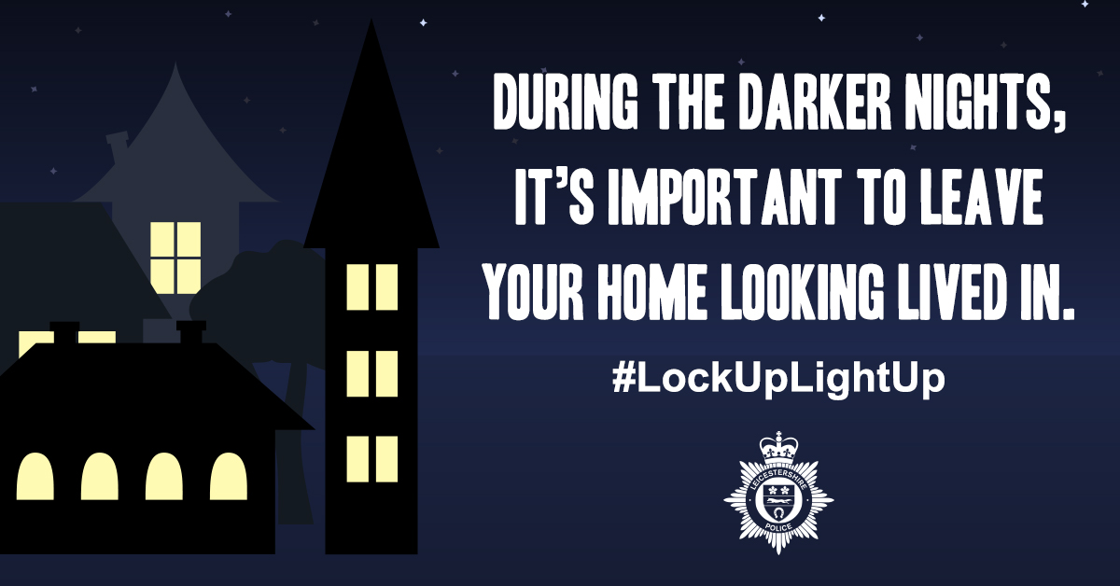

OPERATION SCEPTRE
Leicestershire Police supported the national week of action , education and awareness-raising to tackle knife crime and violence.
This operation is about education and enforcement and is designed to educate young people about the dangers and consequences of carrying a knife ; target those who carry weapons and disrupt the sale and supply of knives.
As part of this initiative the Forest Beat Team conducted knife sweeps in Measham parks.
Locations visited included Bosworth Road Skate Park and Millennium Green.
It will be reassuring to know that no knives were recovered.

Neighbourhood Link is a community messaging service from Leicestershire Police that provides news and
Information about policing activity or initiatives, crime prevention advice as well as major incidents affecting your area.
Through this service you can receive messages from your local Neighbourhood Policing Team, local police or, in the event of a major incident or event affecting the whole of Leicestershire, from a partnership of agencies known as the Local Resilience Forum.
In order to receive messages you will need to register your details. Registration is free and simple to follow.

- Sign up to Neighbourhood Link https://www.neighbourhoodlink.co.uk/
- If you are already registered you can amend your details
- Request a reminder if you have forgotten your username or password • You can unsubscribe from the service at any time

Do you use a ‘community whatsapp group’? If so please consider sharing neighbourhood link information on there to encourage others to join.
Neighbourhood Link is not able to receive messages and you should not use it to contact the police. In an emergency always dial 999. If you wish to contact Leicestershire Police in other circumstances, for example to speak to local police or seek advice on police matters, you can call us by dialling 101 on your telephone.
•If you are already registered you can amend your details
•Request a reminder if you have forgotten your username or password
•You can unsubscribe from the service at any time
Neighbourhood Link is not able to receive messages and you should not use it to contact the police. In an emergency always dial 999. An emergency is when a crime is happening, someone suspected of a crime is nearby, someone is injured, being threatened or in danger.

If you wish to contact Leicestershire Police in other circumstances, for example to speak to local police or seek advice on police matters, you can call us by dialling 101 on your telephone.

