FOREST BEAT parish council report

Police update

1st – 31st MARCH 2023

**BEAT TEAM CONTACTS:**

If you need to contact a member of your beat team and the enquiry isn’t urgent then the easiest way to do this is via email, you can either do this through the Leicestershire Police website or on the details below: **Please do not report crime or Incidents via emails as the messages are not always monitored.**

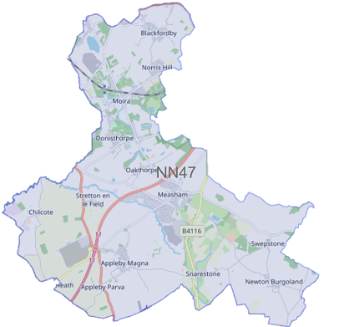North West Leicestershire Police [northwestleicestershire.npa@leicestershire.pnn.police.uk](mailto:northwestleicestershire.npa@leicestershire.pnn.police.uk)

SGT 1341 Nick Leeland

[nick.leeland@leicestershire.pnn.police.uk](mailto:nick.leeland@leicestershire.pnn.police.uk)

PC 1389 Russell Leech

[russell.Leech@leicestershire.pnn.police.uk](mailto:russell.Leech@leicestershire.pnn.police.uk)

PC 1234 Owain Jones

owain.jones@leics.police.uk

PCSO 6686 Madeline Fearn

[madeline.fearn@leicestershire.pnn.police.uk](mailto:madeline.fearn@leicestershire.pnn.police.uk)

Did you know you can report crime and incidents using our online portal?

Please visit <https://www.leics.police.uk/> Click on REPORT.  
In an emergency dial 999

Visit our website for details on crime prevention

<https://www.leics.police.uk/cp/crime-prevention/>

**CRIME FIGURES:** please click the link to show the latest available crime figures in the Forest Beat Area, beat team information, policing priorities and meeting and events.

<https://www.police.uk/pu/your-area/leicestershire-police/forest/>

**Last week, officers from North West Leicestershire Police conducted a 'Fatal Four' operation across your area.**This operation targets four of the main offences related to the use of public roads. These are:  
  
-Speeding  
-Failing to wear a seatbelt  
-Drink and drug driving  
-And Mobile Phone offences.  
  
During the operation, over 100 tickets have been issued for excess speed/ the use of mobile phones/ and failing to wear a seatbelt. 3 people have been dealt with for possession of drugs, 2 people were arrested for drug driving, 1 vehicle was seized for driving without insurance, 1 person was dealt with for driving other than accordance with a license and finally, 17 people were issued words of advice relating to their manner of driving.  
  
The above figures are unacceptable!  
Statistically, the risk of a pedestrian dying is four times higher when they are hit at 40mph in comparison to being hit at 30mph. Speeding kills.  
  
We complete these operations to save lives, to prevent serious injuries, and to detect and disrupt criminals. The law is in place for yours and other road user’s safety.  
  
If you witness’s any road traffic offences taking place on roads near you, then please let us know. You can do this by contacting us by any of the following means:  
  
-By phone- 101 (or 999 in an emergency)  
-By email- contactus@leicestershire.pnn.police.uk  
-By social media. Either on Leicestershire Police on Twitter or Northwest Leicestershire Police on Facebook.  
-Or even by visiting one of our front enquiry offices. Located around Leicester, Leicestershire and Rutland.

**Don’t forget to follow North West Leicestershire Police on Facebook and Twitter for up to date news and events**

We thank you for your continued support and encourage you to report any incident.

By calling 101 (or 999 in an emergency)

By e-mailing - [contactus@leicestershire.pnn.police.uk](mailto:contactus@leicestershire.pnn.police.uk)

Or via social media on Twitter or Facebook

Alternatively, you can report anything anonymously to Crimestopper’s either online or by calling 0800 555 111

**POLICE REPORT 1st to 31st March 2023**

**ACRESFORD**

18/03/2023 – Measham Road – 2 vehicle RTC – no injuries

**ALBERT VILLAGE**

02/03/2023 – Occupation Road – reports of vehicle over weight restriction

8/03/2023 – Occupation Road – dangerous driving

22/03/2023 – Covert Place – vehicle rear windscreen smashed

25/03/2023- Mushroom Lane – 2 vehicle RTC

**APPLEBY MAGNA**

05/03/2023 – Measham Road – theft of vehicle

15/03/2023 – Mcdonald’s – theft of mobile phone

22/03/2023 – Norris Hill – attempt theft of vehicle

**APPLEBY PARVA**

**BLACKFORDBY**

02/03/2023 – Main Street – abandoned vehicle

21/03/2023 - Heath Lane – stolen vehicle

31/03/2023- South Close – house window smashed

**DONISTHORPE**

15/03/2023 – Ashby Road – van rolled into front garden

**MEASHAM**

03/03/2023 – Ashby Road – abandoned vehicle

04/03/2023 – Oak Close – theft of number plates

09/03/2023 – Peggs Close – stolen vehicle found

12/03/2023 – Co-op High Street – suspected attempted break in

13/03/2023 – Bosworth Road - Victim has got into her courtesy vehicle to find the cover over the wires inside the car has been prised off and the vehicle unlocked

18/03/2023 – High Street – report of a car parked on the zig zags

20/03/2023 North Walk – 1 vehicle RTC into lamppost

22/03/2023 – Wigeon Drive – theft of vehicle

22/03/2023 – Tesco Express- Group of youths shouting racial slurs at a security guard

24/03/2023 – Meadow Gardens – derelict building on fire

24/03/2023 -Orchard Way – theft of motor vehicle

27/03/2023 – High Street – male drinking in the street

**MOIRA**

02/03/2023 – Cherry Tree Court – number plate stolen from vehicle

03/03/2023 – Measham Road – RTC – motorbike and car – no injuries

16/03/2023 – Chestnut Close – tools stolen from garage

20/03/2023 – CO-OP, Shortheath Lane – theft of items

23/02/2023 – Norris Hill – electric bike stolen

23/02/2023 – Moira Miners Welfare Club – On-going criminal damage to the whippet racing track running rails, wooden post and club banner.

27/03/2023 – Blackfordby Lane – suspicious male in van

27/03/2023 – Co-op – male stole 3 crates of beer from shop

**NEWTON BURGOLAND**

**OAKTHORPE**

02/03/2023 – Measham Road – vehicle reported with no tax or MOT

07/03/2023 - A42 from Oakthorpe Parish Boundary – 2 vehicle RTC- no injuries

**SNARESTONE**

**STRETTON EN LE FIELD**

07/03/2023 – Burton Road – minor RTC no injuries

16/03/2023 – Layby of A444 – theft of engineering equipment

**SWEPSTONE**

Please ensure that you safely lock and secure all your property including vehicles, garden sheds and outbuildings and your home. Ensure you leave a light on at night to deter thieves who prefer working in the dark

* We will endeavour to provide regular patrols across the beat and will continue to deal with any reported incidents accordingly.

**NEIGHBOURHOOD LINK**

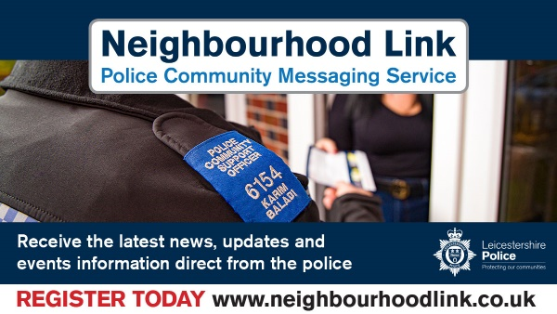Neighbourhood Link is a community messaging service from Leicestershire Police that provides news and information about policing activity or initiatives, crime prevention advice as well as major incidents affecting your area.

Through this service you can receive messages from your local Neighbourhood Policing Team, local police or, in the event of a major incident or event affecting the whole of Leicestershire, from a partnership of agencies known as the Local Resilience Forum.

In order to receive messages you will need to register your details. Registration is free and simple to follow.

• Sign up to Neighbourhood Link <https://www.neighbourhoodlink.co.uk/>

• If you are already registered you can amend your details

• Request a reminder if you have forgotten your username or password

• You can unsubscribe from the service at any time

Do you use a ‘community whatsapp group’? If so please consider sharing neighbourhood link information on there to encourage others to join.

Neighbourhood Link is not able to receive messages and you should not use it to contact the police. In an emergency always dial 999. If you wish to contact Leicestershire Police in other circumstances, for example to speak to local police or seek advice on police matters, you can call us by dialling 101 on your telephone.

•If you are already registered you can amend your details

•Request a reminder if you have forgotten your username or password

•You can unsubscribe from the service at any time

Neighbourhood Link is not able to receive messages and you should not use it to contact the police. In an emergency always dial 999. An emergency is when a crime is happening, someone suspected of a crime is nearby, someone is injured, being threatened or in danger.

If you wish to contact Leicestershire Police in other circumstances, for example to speak to local police or seek advice on police matters, you can call us by dialling 101 on your telephone.

****[**https://www.neighbourhoodlink.co.uk/**](https://www.neighbourhoodlink.co.uk/)

untitled2