MERRY CHRISTMAS AND A HAPPY NEW YEAR FROM THE FOREST BEAT TEAM
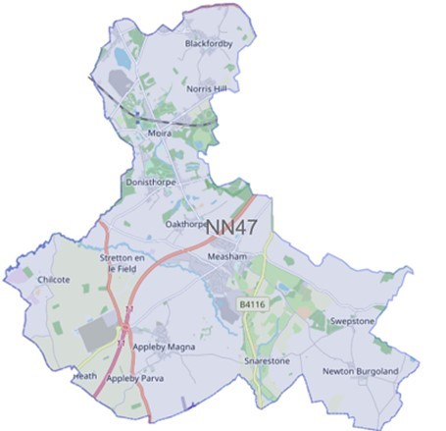
We have listened to you and the concerns you raised and will prioritise the following in October 2023. New beat priorities will be set in January 2024.

Issue: December 2023

Forest Beat

Newsletter

Your Local Team

What matters to you

SGT Gary Sirrell

PC Russ Leech

PC Owain Jones

PCSO Maddie Fearn

Priority 1: ASB and Criminal Damage
You said: Criminal Damage and Anti-Social Behaviour at Woodlands Way, Moira and surrounding areas is of concern to you.
What we are going to do: *Targeted Patrols *Intelligence development

Priority 2: Road Safety
You Said: HGV’s breaching the weight limit was of concern to you on the Forest Beat
What we are going to do: *Targeted patrols - partnership working

Priority 3: Anti-Social Behaviour
You Said: Anti-Social Behaviour on High Street, Measham and surrounding areas.
CRIME FIGURES
Please click the link to show the latest available crime figures in the Forest Beat Area, beat team information, policing priorities and meeting and events.
https://www.police.uk/pu/your-area/leicestershire-police/forest/

News

To read all the latest news please follow the link
News | Leicestershire Police (leics.police.uk)

Crime Prevention

Visit our website for details on crime prevention https://www.leics.police.uk/cp/crime-prevention/
What we are doing
- Community Consultations to hear your views which assists us in priority setting in the future.
- Regular patrols of hotspot ASB area’s
- Visiting schools, youth groups and community meetings
- Regular patrols of Moira Furnace, Hicks Lodge and local park areas.
- We plan to be visible in crime hotspots across the area to reduce criminal behaviour
Please help the Forest beat to understand your concerns by completing the following surveys
- Confidence Survey Your Views Survey

Police
Report
Moira Road, Donisthorpe – vehicle collided with stationary vehicle
Gallows Lane, Measham – 2 vehicle RTC
Tamworth Road, Measham – attempted theft of motorcycle
Wigeon Drive, Measham – theft of motorcycle
Netherseal Road, Chilcote – machinery and tools stolen
Fearns Garage, Albert Village – vehicle windows smashed
Co-op Stores, Moira – theft of items
Willow Close, Measham – damage to vehicle
School Street, Oakthorpe – oil stolen from outside oil container.
Church Street, Donisthorpe – Anti-social behaviour

Protect your motorcycle, moped or scooter from theft
Thieves only need a matter of seconds to steal a moped, scooter or motorcycle - especially if they are left with poor security - but our tips will help reduce the chance of theft.

Lock, chain, cover
Reduce your risk of becoming a victim by taking steps to layer your security.
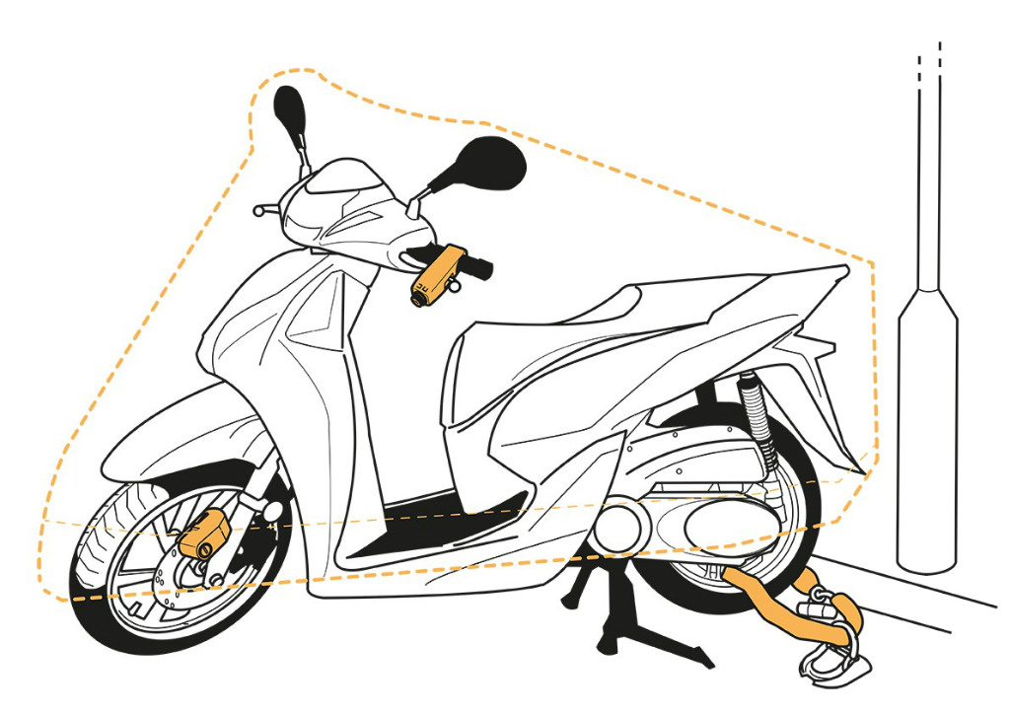

Lock
Use a disc lock to help secure the front brake disc, or a grip lock to secure the brake and throttle controls. You could also use a D lock on the front wheel to stop it being wheeled away.

Chain
Thieves often steal a bike by breaking the steering lock and wheeling it away. Use a chain lock through the back wheel (the front wheel can be removed). Secure your bike, with the lock taut to an immovable object such as a ground anchor or street furniture. This will stop thieves from cutting a lock trailing on the ground using an angle grinder. If this isn’t possible, thread the chain through your bike frame and back wheel.

Cover
Thieves often ‘shop’ for bike models. Using a cover instantly makes it less attractive to them. A cover also provides another time-consuming obstacle for the thief.
Unfortunately security measures can’t guarantee your bike won’t be stolen but, by using multiple security measures, you can make it harder and less attractive for thieves.
For security products for your scooter, motorcycle or moped search the ‘Accredited products’ page on Secured by Design (a police-approved website).

Remove the keys
Thieves are often opportunists and so they will look for bikes that are quick and easy to steal first.
- Always use the steering lock and remove the ignition keys, even if you are close by or away for a few minutes. It only takes a few seconds for a thief so don’t make it easy for them.
- Never rely on just using your steering lock to secure your bike as thieves can break the steering lock and simply wheel the bike away.

Fitting an alarm can be a deterrent to thieves

- Consider fitting a Thatcham-rated 1 or 2 alarm system with tracking, immobilisation, anti-grab and movement sensors can help protect and trace your vehicle.
- A quality Thatcham approved, professionally fitted alarm system will not only put off thieves, but could also reduce your insurance premiums.

Property - mark the parts

- Marking as much of your bike as possible will make it more difficult for criminals to sell parts on, and therefore less attractive to steal. It will also help police identify parts and return recovered stolen bikes.
- There are a range of bike marking providers that you can use.

When at home the best place to keep your motorcycle, moped or scooter is in your garage or shed
- Fit a garage door defender or upgrade garage door locks.
- Garage and shed alarms as well as low level dusk to dawn lighting will also enhance security. Fitting a ground anchor also provides extra security.
- Motorcycle lockers are also available to store your bike at home.
Find out more about shed and garage security.

No shed or garage? Park in the safest place you can
- Park it in an area near to your home where it’s well overlooked with good lighting.
- A Park Mark approved car park has a higher level of security than other car parks.
If your bike is stolen, never put yourself at risk. Call police immediately on 999 if you see it being stolen or report a crime online or call 101 if you discover it has gone.

Help us to reduce further crime
Stolen scooters are increasingly being used to commit further crimes, such as phone snatches. By protecting your scooter you could help to reduce these other crimes.
Find out more about how to protect your phone from thieves on bikes and scooters.

As the darker nights draw in, it's important to leave your home looking lived in. 🌙
This could be as simple as setting up lights on a plug timer whilst you are out. ⏲️
More advice to secure your home ➡️ https://orlo.uk/vr92R

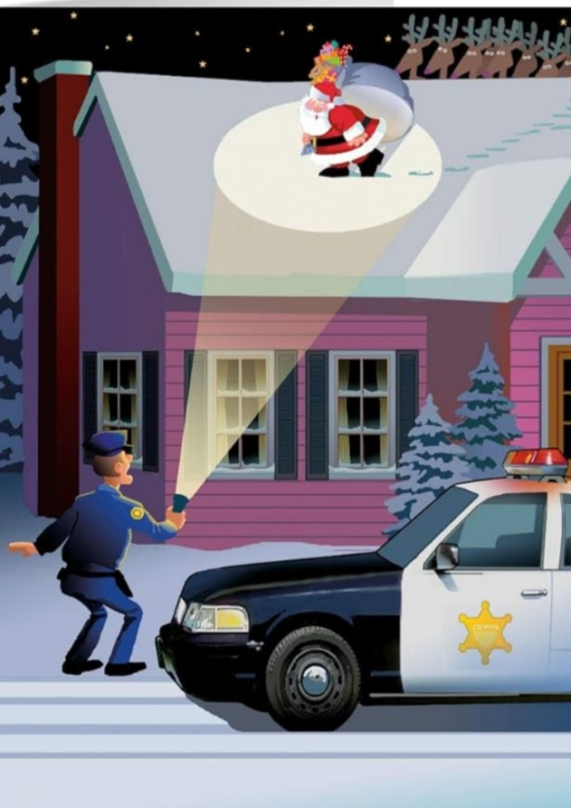

Neighbourhood Link is a community messaging service from Leicestershire Police that provides news and
Information about policing activity or initiatives, crime prevention advice as well as major incidents affecting your area.
Through this service you can receive messages from your local Neighbourhood Policing Team, local police or, in the event of a major incident or event affecting the whole of Leicestershire, from a partnership of agencies known as the Local Resilience Forum.
In order to receive messages you will need to register your details. Registration is free and simple to follow.

- Sign up to Neighbourhood Link https://www.neighbourhoodlink.co.uk/
- If you are already registered you can amend your details
- Request a reminder if you have forgotten your username or password • You can unsubscribe from the service at any time

Do you use a ‘community whatsapp group’? If so please consider sharing neighbourhood link information on there to encourage others to join.
Neighbourhood Link is not able to receive messages and you should not use it to contact the police. In an emergency always dial 999. If you wish to contact Leicestershire Police in other circumstances, for example to speak to local police or seek advice on police matters, you can call us by dialling 101 on your telephone.
•If you are already registered you can amend your details
•Request a reminder if you have forgotten your username or password
•You can unsubscribe from the service at any time
Neighbourhood Link is not able to receive messages and you should not use it to contact the police. In an emergency always dial 999. An emergency is when a crime is happening, someone suspected of a crime is nearby, someone is injured, being threatened or in danger.

If you wish to contact Leicestershire Police in other circumstances, for example to speak to local police or seek advice on police matters, you can call us by dialling 101 on your telephone.

