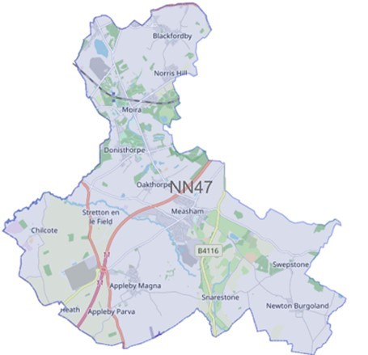

Issue: January 2024

Forest Beat

Newsletter

Your Local Team

What matters to you

SGT Gary Sirrell

PC Russ Leech

PC Owain Jones

PCSO Maddie Fearn

We have listened to you and the concerns you raised and will prioritise the following in January 2024 through to March 2024

Priority 1: ASB – Moira Furnace
Anti-social behaviour at Moira Furnace in particular off-road bikes and drug taking.
What we are going to do: Complete targeted patrols to disrupt and challenge behaviour. Intelligence development. Challenge those involved and work with partner agencies to implement outcomes.

Priority 2: Drug Dealing
Drug dealing around the Oakthorpe area.
What we are going to do: Complete targeted patrols to disrupt and challenge behaviour - Intelligence development. Challenge those involved and work with partner agencies to implement outcomes.

Priority 3: Vehicle Crime
Vehicle crime in Measham in particular motorbike thefts in the Atherstone Road area.
What we are going to do: Complete targeted patrols to disrupt and challenge behaviour - Intelligence development

Please click the link to show the latest available crime figures in the Forest Beat Area, beat team information, policing priorities and meeting and events.
https://www.police.uk/pu/your-area/leicestershire-police/forest/

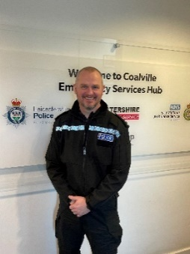
News

To read all the latest news please follow the link
News | Leicestershire Police (leics.police.uk)
The North-West Leicestershire policing area has a new Inspector.
Insp Steve Burge has recently become the new Neighbourhood Policing Commander for Coalville, taking over from Wayne Nimblette, who has moved into a new role at Force Headquarters as a Chief Inspector.
Insp Burge joins the team after a 15-month period in charge of operations training at Police Headquarters. He brings a wealth of experience with him, having worked in a wide variety of roles across the force.
“I have been a police officer for twenty-six years, working within and leading response, proactive, custody and training teams, which has given me a good foundation to lead the dedicated team of officers and police staff at Coalville NPA.
I strongly believe that the key to problem solving issues is through building strong relationships with our partners and the communities we serve and look forward to developing these partnerships as we enter 2024.
I have inherited a great team from my predecessor Insp Wayne Nimblette whose legacy I aim to continue to ensure that North West Leicestershire is a safe place to live, work and visit”.

Crime Prevention

Visit our website for details on crime prevention https://www.leics.police.uk/cp/crime-prevention/
What we are doing
- Community Consultations to hear your views which assists us in priority setting in the future.
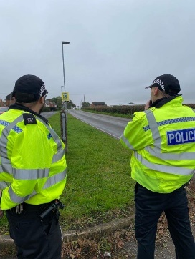
- Regular speed checks
- Regular patrols of hotspot ASB area’s
- Visiting schools, youth groups and community meetings
- Regular patrols of local park areas.
- We plan to be visible in crime hotspots across the area to reduce criminal behaviour.

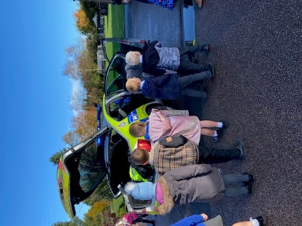
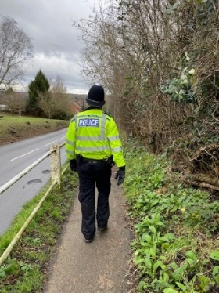

Please help the Forest beat to understand your concerns by completing the following surveys.
- Confidence Survey Your Views Survey

- Anti-social behaviour at the bus shelters on High Street and Burton Road, Measham.
- Co-op Store, Shortheath Road, Moira – theft of goods
- Leicester Road, Measham – 2 vehicle RTC
- Dennis Way, Measham – theft of tools from van
- Main Street, Newton Burgoland – damage to vehicle
- Raven Close, Measham – fence panels stolen
- Measham Road, Oakthorpe – robbery and shopkeeper attacked (see below)
- Burton Road bus shelter, Measham – anti-social behaviour
- Peggs Close, Measham – stolen vehicle
- Wilkes Avenue – stolen motorbike
- Bus shelter Burton Road, Measham – anti-social behaviour
- Gallows Lane – pedestrian hit by car
- Measham Road, Acresford – 2 vehicle RTC
- Bosworth Road, Measham – theft of motor vehicle
- Strawberry Lane, Blackfordby – theft of motor vehicle
Can you help?
Detectives are appealing for anyone with dashcam or doorbell footage to come forward after a shopkeeper was assaulted during a robbery in Oakthorpe.
The incident happened at premises in Measham Road at around 6pm on Saturday (13 January). The victim, a man in his 60s, was hit with a hammer by a man, who made off with the cash drawer from the till.
The victim is continuing to receive treatment for a head injury.
Following initial enquiries, a 37-year-old man was arrested on suspicion of robbery. He has since been released on bail.
PC Amy Aplin, the investigating officer, said: “While a man has been arrested in connection with this incident, we’re still appealing for anyone who can help, but has not yet come forward, to do so.
“I’m particularly keen to speak to anyone who was in the area at the time and has a dashcam in their vehicle or anyone living nearby who has a doorbell camera. Did you see anyone around the time this incident occurred whose behaviour seemed odd, suspicious or out of character?
“Anything you can tell us, no matter how insignificant you think it is, could help.”
You can pass on information by visiting https://orlo.uk/HOZXJ and quoting reference 24*26531

Beat Surgeries for February
Friday 16th February 10:00 – 12:00 Donisthorpe Woodlands Centre
Friday 23rd February 10:00 – 12:00 AGE UK, High Street, Measham

Neighbourhood Link is a community messaging service from Leicestershire Police that provides news and
Information about policing activity or initiatives, crime prevention advice as well as major incidents affecting your area.
Through this service you can receive messages from your local Neighbourhood Policing Team, local police or, in the event of a major incident or event affecting the whole of Leicestershire, from a partnership of agencies known as the Local Resilience Forum.
In order to receive messages you will need to register your details. Registration is free and simple to follow.

- Sign up to Neighbourhood Link https://www.neighbourhoodlink.co.uk/
- If you are already registered you can amend your details
- Request a reminder if you have forgotten your username or password • You can unsubscribe from the service at any time

Do you use a ‘community whatsapp group’? If so please consider sharing neighbourhood link information on there to encourage others to join.
Neighbourhood Link is not able to receive messages and you should not use it to contact the police. In an emergency always dial 999. If you wish to contact Leicestershire Police in other circumstances, for example to speak to local police or seek advice on police matters, you can call us by dialling 101 on your telephone.
•If you are already registered you can amend your details
•Request a reminder if you have forgotten your username or password
•You can unsubscribe from the service at any time
Neighbourhood Link is not able to receive messages and you should not use it to contact the police. In an emergency always dial 999. An emergency is when a crime is happening, someone suspected of a crime is nearby, someone is injured, being threatened or in danger.

If you wish to contact Leicestershire Police in other circumstances, for example to speak to local police or seek advice on police matters, you can call us by dialling 101 on your telephone.

